Day-1 Introduction to Data Analytics and Data Science
Date: -13/10/2026

Task: Understand Data analytics, Data science, business Intelligence, and data Project lifecycle.

- Difference between data analytics and data science.
- Understand descriptive, predictive, and prescriptive analytics.
- Study how organizations collect, store, process, and analyze data.
- Understand the roles of Data Analyst, Business Intelligence Analyst, Data scientist and Data Engineer.
- Draw a workflow showing how raw data becomes a business decision.

- Difference between data analytics and data science: -

Data analytics is the process of examining data to find useful information, understand what is happening, and support decisions.
Data analytics commonly involves:
- Collecting relevant data.
- Cleaning incorrect, missing, or duplicate records.
- Organizing and querying data.
- Calculating totals, averages, percentages, and other measurements.
- Creating reports, charts, and dashboards.
- Identifying trends and explaining results.
- Communicating findings to help people make decisions.
The main purpose: Turn existing data into understandable information that supports decisions.

Data science is a broader field that uses statistics, programming, mathematics, domain knowledge, and often machine learning to extract insights from data and build models that learn patterns.
It can include data analytics, but it also commonly involves more advanced predictive and computational tasks.
Typical activities include:
- Exploring and preparing data.
- Applying statistical methods.
- Identifying complex patterns.
- Developing machine learning models.
- Predicting future outcomes.
- Classifying information into categories.
- Building recommendation systems.
- Evaluating and improving models.
- Deploying models into applications or business systems.
The main purpose: Discover patterns, build useful models, and solve data-driven problems, including predicting outcomes.

Data Analytics | Data Science
Understand data and support decisions | Extract deeper patterns and build data-driven models
SQL queries, statistics, reports, dashboards | Statistics, experimentation, machine learning, modelling
Reports, dashboards, findings, recommendations | Predictive models, experiments, algorithms, insights
Explain why sales decreased | Predict which customers may stop purchasing

- Understand descriptive, predictive, and prescriptive analytics: -
Organizations ask different types of questions about their data. These three types of analytics help answer different questions.
Imagine an online store that sells books.

Descriptive analytics
Question: What happened?
Descriptive analytics summarizes historical or current data so we can understand what has happened or what is happening
E.g: Total, average, minimum, and maximum calculation’s, etc.

Predictive analytics
Question: What is likely to happen?
Predictive analytics uses historical data, statistical methods, and sometimes machine learning to estimate future outcomes or unknown values.
E,g: Using several years of sales records, a business estimates next month's sales.

Prescriptive analytics
Question: What should we do?
Prescriptive analytics uses information about the situation, possible actions, constraints, and expected outcomes to recommend what action to take.
E.g: Expected demand, Supplier prices, Delivery times, Storage capacity, Available budget.

- Study how organizations collect, store, process, and analyze data: -

Stage 1: Data collection
Data collection means gathering information from different sources (Websites, Surveys and feedback).

Stage 2: Data storage
After collection, data must be stored so that it can be retrieved, updated, protected, and analyzed (Database, Data warehouse)

Stage 3: Data processing
Raw data is often incomplete, inconsistent, duplicated, or difficult to use directly. Processing makes it more reliable and suitable for analysis. (Cleaning, Transformation, Integration, Validation, Aggregation)

Stage 4: Data analysis
Once the data is ready, analysts examine it to answer business questions.

Stage 5: Business decision and monitoring
Analysis alone does not create business value. Someone must interpret the findings and decide what to do.

- Understand the roles of Data Analyst, Business Intelligence Analyst, Data scientist and Data Engineer:

4.1 Data Analyst:
Investigate data and explain findings that help answer business questions.
The data analyst compares sales across products, regions, and time periods and reports the main contributing factors.
Common skills: SQL, Excel, Python or R, statistics, data visualization, and communication.
4.2 Business Intelligence (BI) Analyst:
Help organizations monitor performance and make informed decisions through reports, dashboards, and business metrics.
The BI analyst creates a dashboard, often using Power BI or Tableau, so the director can monitor these measures.
Common skills: SQL, Power BI or Tableau, data modelling, business understanding, and reporting.
4.3 data scientist:
Use statistical methods, experimentation, and often machine learning to uncover patterns and develop models.
A data scientist develops and evaluates a model using historical customer behavior, then explains how reliably it predicts cancellations.
Common skills: Python, SQL, statistics, probability, machine learning, data visualization, and model evaluation.
4.4 Data Engineer:
Main responsibility: Build and maintain the systems that make reliable data available to analysts, BI specialists, and data scientists.
A data engineer builds a reliable pipeline that brings these sources together so analysts can use consistent information.
Common skills: SQL, Python or another programming language, databases, ETL/ELT, data modelling, cloud platforms, and distributed data-processing tools where needed.
- Draw a workflow showing how raw data becomes a business decision:

1.Data collection: Raw data from the app
(Orders, delivery times, locations, traffic, and restaurant preparation times)

2. Data Analyst 3. BI Analyst
Finds which areas, restaurants, or time Builds a dashboard to track delays,
periods have the most delays. targets, and performance over time.

4. Data Scientist
Develops a model to estimate which orders are at risk of arriving late.

5.Business decision
The operations manager adjusts delivery assignments,
restaurant coordination, or estimated delivery
times and then measures the results.

Learning outcome:
- Data analytics turns data into insights for decisions. Data science uses data, statistics, and computational methods to discover patterns and develop models.
- Descriptive analytics explains what happened. Predictive analytics estimates what may happen. Prescriptive analytics helps determine what action to take.
- Data engineers build and maintain reliable data systems. Data analysts investigate questions and interpret results. BI analysts build reporting and performance-monitoring solutions. Data scientists develop statistical and machine learning models.
- The complete workflow: Collect → Store → Process → Analyze → Communicate → Decide → Evaluate.
Day-2 Python programming fundamentals-I
Date: -14/10/2026

Task: Understand Data analytics, Data science, business Intelligence, and data Project lifecycle.

- Install and configure python
- Learn variables, integers, float, string, and Boolean values.
- Practice arithmetic, comparison, and logical operators.
- Use input() and print()
- Write program for calculating percentage, sales totals, discounts, and averages.

- Learn variables, integers, float, string, and Boolean values:-

A variable is a name used to refer to a value in a program.
E.g: name = "Asha"
Here name, marks and age are variables
marks = 450
age= 19

Rules for naming variables:
- Cannot start with a number
- Cannot contain spaces
- Cannot use Reserved Python keyword as variable
- Can only use underscore symbol

A data type tells Python what kind of value you are working with.

- Integer (int)
Whole numbers without a decimal part.
E.g: 10, 250, -5, 0

- Float (float)
Numbers that contain a decimal point.
Examples: 10.5, 99.99, 3.14

- String (str)
Text enclosed in single or double quotation marks.
Examples: "Hello", "Python", "123"

- Boolean (bool)
Represents one of two values: True or False.
Note: Python provides the type() function to check type of variable.

- Practice arithmetic, comparison, and logical operators:-
An operator is a symbol or keyword that performs an operation on values

- Arithmetic operator:
Arithmetic operators perform mathematical calculations.
a = 10
b = 3
Operator | Meaning | Example | Result
+ | Addition | a + b | 13
- | Subtraction | a - b | 7
* | Multiplication | a * b | 30
/ | Division | a / b | 3.333...
// | Floor division | a // b | 3
% | Remainder | a % b | 1
** | Exponentiation | a ** b | 1000

- Comparison operator:
Comparison operators compare two values and return a Boolean result: True or False.

Operator | Meaning | Example | Result
= = | Equal to | 5= =5 | True
!= | Not equal to | 5!=3 | True
> | Greater than | 8>5 | True
< | Less than | 2<1 | False
>= | Greater than or equal to | 5>=5 | True
<= | Less than or equal to | 3<=5 | True

- Logical Operator:
Logical operators combine conditions or reverse a condition.
Python has three main logical operators.
- and: Both conditions must be true.
- or: At least one condition must be true.
- not: Reverses a Boolean value.

- Use input() and print() : -
These are two of the most important Python functions for beginner programs.

- input() allows a program to receive information from the user.
name = input("Enter your name: ") o/p Enter your name: Shivani
print("Welcome,", name) Welcome, Shivani

- print() displays information on the screen.
name = "Shivani"
age = 21
print(name) o/p Shivani
print(age) 21
print("Welcome to Python") Welcome to Python

Using f-strings
An f-string lets you insert variable values directly into a string.
name = "Asha"
percentage = 90.5
print(f"{name} scored {percentage}%") o/p Asha scored 90.5%

- Write program for calculating percentage, sales totals, discounts, and averages:

- Calculate Percentage:
marks = 400
total_marks = 500
percentage = (marks / total_marks) * 100
print("Percentage:", percentage, "%") o/p Percentage: 80.0 %

- Calculate Total Sales:
price = 100
quantity = 5
total_sales = price * quantity
print("Total Sales: Rs.", total_sales) o/pTotal Sales: Rs. 500

- Calculate Discount:
price = 1000
discount = 10
discount_amount = price * discount / 100
final_price = price - discount_amount
print("Discount Amount: Rs.", discount_amount) o/p Discount Amount: Rs. 100.0
print("Final Price: Rs.", final_price) Final Price: Rs. 900.0

- Calculate Average:
a = 10
b = 20
c = 30
average = (a + b + c) / 3
print("Average:", average) o/p Average: 20.0

Day-3 Python Programming Fundamentals-II
Date: -15/10/2026
Task: Learn conditional statements, loops, collections, and functions.

- Practice if, elif, and else.
- Learn for and while loops.
- Work with lists, tuples, sets, and dictionaries.
- Create reusable functions.
- Solve exercises involving calculating totals, finding maximum values, counting categories, and removing duplicates.

- Practice if, elif, and else:-

A conditional statement allows a program to make a decision based on whether a condition is true or false. Python uses if, elif, and else to make these decisions.

- The if statement
The if statement executes a block of code only when its condition is true.
E.g: marks = 75
if marks >= 40:
print("Pass") o/p Pass

- The if-else statement
Use else when you want to specify what happens if the if condition is false.
E.g: marks = 30
if marks >= 40:
print("Pass")
else:
print("Fail") o/p Fail

- The if-elif-else statement
Use elif (short for "else if") when you need to check multiple conditions.
E.g: marks = 85
if marks >= 90:
print("Grade A+")
elif marks >= 80:
print("Grade A")
elif marks >= 70:
print("Grade B")
elif marks >= 40:
print("Pass")
else:
print("Fail") o/p Grade A

- Learn for and while loops: -
A for loop is useful when you want to process each item in a collection or repeat an operation a known number of times.
E.g: Print numbers from 1 to 5
for i in range(1, 6): (The ending value, 6, is excluded.)
print(i)

o/p 1
2
3
4
5

A while loop continues as long as its condition is true.
E.g: Print numbers from 1 to 5
While(i<=5)
print (i)

For loop | While loop
Iterates through items or a sequence of values | Repeats while a condition is true
Often convenient when processing a list | Often convenient when repetition depends on a condition
Example: Process every product in a list | Example: Continue until the user enters a valid response

break and continue
These statements control how a loop runs.
- break immediately exits the loop.
- continue skips the rest of the current iteration and moves to the next one.

- Work with lists, tuples, sets, and dictionaries.: -

- List:
A list stores multiple items in a specific order. Lists are mutable, meaning you can change their contents after creating them.
Python uses zero-based indexing. This means the first item is at index 0, the second at index 1, and so on.
You can also use negative indexes to access elements from the end.
Use a list when you need an ordered collection that may change.
Syntax: listname= [value1,value2,….,value n]

Method | Purpose
append(x) | Add an item to the end
insert(i,x) | Insert an item at a particular position
remove(x) | Remove the first matching item
pop() | Remove and return the last item by default
sort() | Sort the list in place
count(x) | Count occurrences of an item
- Tuple:
A tuple also stores multiple items in order, but it is immutable. Once created, you cannot replace, add, or remove its individual elements.
You can access tuple items using indexes, just as you do with lists.
Python raises a TypeError because tuple elements cannot be reassigned.
Syntax: tuplename= (value1,value2,….,value n)

Method | Purpose
Min(tuplename) | To find minimum greatest value from tuple
max(tuplename) | To find maximum smallest value from tuple
len(tuplename) | To find number of values in tuple

- Set:
A set is a collection of unique elements. If you add the same value multiple times, the set stores only one copy.
Sets are useful for removing duplicates and checking membership.
Important set properties:
- Sets contain unique elements.
- Sets do not provide positional indexing like lists.
- Sets are mutable, so elements can be added or removed.
- A set's elements must be hashable; lists and dictionaries cannot be elements of a set.
Syntax: set_name= { value1,value2,….,value n }

Method | Purpose
add() | Add new element
remove() | Remove existing element

- Dictonary:
A dictionary stores information as key-value pairs.
Think of it as a labelled record: each key identifies a value.
Use a dictionary when you want to associate one piece of information with another.
Syntax: dict_name= {‘key1’:value1,’Key2’:value2,….}

Method | Purpose
keys() | Return list of keys
values() | Return list of values
pop() | Remove last key and value
popitem() | Remove specific key
items() | Provide each key and its associated value
clear() | Remove all key-value

- Compare all four
Feature | List | Tuple | Set | Dictionary
Syntax | [ ] | ( ) | { } | {key: value}
Ordered | Yes | Yes | No positional order | Preserves insertion order
Mutable | Yes | No | Yes | Yes
Heterogenous | yes | no | No | yes
Index | yes | yes | No | Key type

- Create reusable functions:
A function is a reusable block of code designed to perform a particular task. Functions make programs easier to read, test, maintain, and reuse.
Creating function:
Syntax: def fun_name (arg):
fun_body
E.g: def hello( ):
print (“Hello Shivani”)
hello( ) o/p Hello Shivani
Types of function:
- Function without argument
- Function with argument
- Function with argument and return type

- Solve exercises involving calculating totals, finding maximum values, counting categories, and removing duplicates:

- Calculate the total
sales = [100, 200, 300]
print("Total:", sum(sales))

- Find the maximum value
numbers = [10, 45, 20, 60, 30]
print("Maximum:", max(numbers))

- Count categories
categories = ["A", "B", "A", "C", "B", "A"]
for c in set(categories):
print(c, ":", categories.count(c))

- Remove duplicates
numbers = [1, 2, 2, 3, 1, 4]
unique = list(dict.fromkeys(numbers))
print(unique)

Day 3: Learning Outcomes
- Learned to use if, elif, and else for decision-making, and for and while loops for repetition.
- Understood lists, tuples, sets, dictionaries, and how to create reusable functions using parameters and return.
- Practiced calculating totals, finding maximum values, counting categories, and removing duplicate values using Python.

Day-4 Python File Handling and Error Handling
Date: -16/10/2026
Task: Learn to read and write files and handle exceptions.
1. Read and write text files.
2. Learn how to work with CSV files.
3. Practice try, except, and finally.
4. Learn how to import Python modules.
5. Create a program that reads a CSV file, checks whether it exists, and handles invalid data.

- Read and write text files:-

File handling is the process of opening, reading, creating, modifying, and closing files through a program.
file.write() Writes text to the file.
file.read() Reads the file's contents into a string.
open() Opens a file or creates it when permitted by the mode.

Modes of file:

Read (r) :-
Reads an existing file. Fails with FileNotFoundError if it doesn't exist.

Write (w) :-
Creates a file or overwrites its existing contents. Use carefully.

Append (a) :-
Adds new content at the end without removing existing content.

- file.readline() — reads one line.
- file.readlines() — reads all lines into a list.
- file.write("text") — writes text.
- file.close() — closes a file manually, though with is usually safer.

Example:
f =open (“Day-1.txt”,”w”)
f=open (“Day-1,txt”,”r”)
f.write (“Welcome to day 4”)
f.close()

- Learn how to work with CSV files: -

CSV stands for Comma-Separated Values. It is a plain-text format used to store tabular data in rows and columns. CSV files can be opened in spreadsheet software, text editors, and Python.
To read CSV as a normal text file you can use file.read() to read CSV text. However, real CSV files may contain commas inside quoted fields, quotation marks, or line breaks within a value.

Create a CSV file:

import csv

with open("sales.csv", "w", newline="") as file:
writer = csv.writer(file)

writer.writerow(["Product", "Quantity", "Price"])
writer.writerow(["Pen", 10, 5])
writer.writerow(["Notebook", 4, 40])
writer.writerow(["Folder", 3, 20])

print("CSV file created.")

- import csv loads Python's CSV module.
- csv.writer(file) creates an object that writes CSV records.
- writer.writerow() writes one row at a time.
- newline="" is the recommended way to open CSV files for writing so that extra blank lines are avoided, particularly on Windows.

- Practice try, except, and finally: -

An exception is an event that interrupts the normal execution of a program. Python raises an exception when it encounters a problem it cannot handle automatically.

- try
Attempt the operation
Place code that might raise an exception here.
- except
Handle the problem
Runs when a matching exception occurs in the try block.
- else
Run after success
Runs if the try block completes without raising an exception.
- finally
Run cleanup code
Runs whether an exception occurred or not, unless execution is forcibly terminated.
Understand try and except:

try:
number = int(input("Enter a whole number: "))
print("You entered:", number)

except ValueError:
print("Invalid input. Please enter a whole number.")

If the user enters 25, the program prints the number. If the user enters hello, Python raises ValueError and the except block handles it.

Example:

try:
number = int(input("Enter a number: "))

except ValueError:
print("That is not a valid integer.")

else:
print("Conversion successful.")
print("Square =", number ** 2)

finally:
print("Program section completed.")

Common exceptions you should recognize

Exception | Typical cause | What to do
PermissionError | The program lacks access to a file. | Check permissions or whether the file is accessible.
FileNotFoundError | The requested file does not exist. | Check the file path or report that it is missing.
ValueError | Text cannot be converted to the required value. | Validate the data and report the bad value.
KeyError | A dictionary key or expected column name is missing. | Check the CSV headers or dictionary keys.
IndexError | A list position does not exist. | Check the list's length before accessing an element.
ZeroDivisionError | The program divides by zero. | Check the denominator first.
TypeError | An operation is used with an incompatible type. | Correct the types or the operation.
csv.Error | The CSV parser encounters a CSV-related error. | Check the file's format and parsing assumptions.

- Learn how to import Python modules :-
A module is a Python file or importable component that provides reusable code, such as functions, classes, and variables.
Instead of writing everything from scratch, you can use existing modules to perform common tasks.
Think of a module as a toolbox. You select the tools you need rather than building every tool yourself.
Example module:
Module | What it does | Eg use
Csv | Reads and writes CSV data. | csv.DictReader(file)
Pathlib | Works with file paths and checks file existence. | Path("sales.csv").exists()
Datetime | Works with dates and times. | datetime.now()
Different ways to import:
# 1. Import the entire module
import csv
print(csv.reader)

# 2. Import a specific class
from pathlib import Path
print(Path("sales.csv").exists())

# 3. Import with an alias
import datetime as dt
print(dt.datetime.now())

Key distinctions:
- import csv lets you access its features using csv..
- from pathlib import Path imports the Path class directly.
- import datetime as dt lets you refer to the module using the shorter name dt.

- Create a program that reads a CSV file, checks whether it exists, and handles . invalid data:-
CSV file: #students.csv
Name,Marks
Asha,85
Rahul,abc
Priya,92

Python program:
import csv
import os

filename = "students.csv"

try:
# Check whether the file exists
if not os.path.exists(filename):
print("Error: CSV file not found.")

else:
# Open and read the CSV file
with open(filename, "r", newline="") as file:
reader = csv.DictReader(file)

for row in reader:
try:
name = row["Name"]
marks = float(row["Marks"])

if not name.strip() or not 0 <= marks <= 100:
raise ValueError("Invalid student data")

print(name, marks)

except ValueError:
print("Invalid data found:", row)

except (OSError, csv.Error) as error:
print("Error:", error)

Output:
Asha 85.0
Invalid data found: {'Name': 'Rahul', 'Marks': 'abc'}
Priya 92.0

Day 4: Learning Outcomes
- Explain how files allow data to persist beyond a program's execution.
- Choose the appropriate file mode and use context managers. Read, write, and process CSV records safely.
- Explain the difference between an exception and a data-validation failure. Use specific exception handlers for common file and data errors.
- Import standard-library modules and organize reusable functions.

Day-5 NumPy for Numerical Computing
Date: -17/10/2026
Task: Learn numerical calculations using NumPy.
1. Install or import NumPy.
2. Create one-dimensional and multidimensional arrays.
3. Practice indexing, slicing, filtering, and reshaping.
4. Calculate sum, mean, minimum, maximum, and standard deviation.
5. Compare basic Python calculations with NumPy operations.

- Install or import NumPy:-

NumPy (Numerical Python) is a Python library used for numerical calculations and working with arrays of data efficiently.
Using ordinary Python, you could write loops and calculations. NumPy provides specialized array operations that make this kind of work simpler and often faster.

Why is NumPy useful?

- Efficiency: Performs many numerical operations without requiring you to write Python loops for every calculation.
- Convenience: Provides built-in functions for statistics, filtering, reshaping, and mathematical operations.
- Consistency: Applies operations to entire arrays in a predictable way.
- Foundation: Used throughout data analysis, scientific computing, machine learning, and AI workflows.

Install and import NumPy:

Step-1 installation
If NumPy is not already installed, open your terminal or command prompt and run:
python -m pip install numpy

We generally install a library once in the Python environment you use. You import it into each Python script or notebook where you need it.

import numpy as np

- Create one-dimensional and multidimensional arrays: -

One-dimensional array (1D)
A 1D array is a single sequence of values, similar to a row of data.
[1200, 1800, 1500, 2200, 1300]

Two-dimensional array (2D)
A 2D array is arranged in rows and columns, like a spreadsheet.
[[100, 150, 200, 180],
[250, 300, 280, 320],
[400, 350, 450, 500]]

Three-dimensional array (3D)
A 3D array can represent multiple 2D tables stacked together.
[
[[100, 150], [200, 250]],
[[300, 350], [400, 450]]
]

- Practice indexing, slicing, filtering, and reshaping:-

- Indexing means retrieving an element using its position.
Python and NumPy use zero-based indexing. The first element is at index 0, the second at index 1, and so on.
Negative indexing counts backward from the end.

import numpy as np
marks = np.array([75, 82, 91, 68, 88])
print(marks[0]) o/p 75

import numpy as np
marks = np.array([
[75, 80, 85],
[90, 88, 92],
[65, 70, 72]])
print(marks[0, 0]) o/p 75

- Slicing selects a range of elements instead of just one.
array[start:stop:step]

import numpy as np
sales = np.array([100, 200, 300, 400, 500, 600])
print(sales[1:4]) o/p [200 300 400]

import numpy as np
data = np.array([
[10, 20, 30, 40],
[50, 60, 70, 80],
[90, 100, 110, 120]]) o/p [ [ 20 30]
print(data[0:2, 1:3]) [ 60 70]]
The expression data [0:2, 1:3] selects:
- Rows with indexes 0 and 1.
- Columns with indexes 1 and 2.

- Filtering is especially useful in data analytics because real datasets often contain thousands of values, and you usually want only a subset.

import numpy as np
marks = np.array([55, 82, 91, 68, 88, 74])
result = marks[marks >= 80]
print(result) o/p [82 91 88]

It creates a Boolean array: [False True True False True False]
NumPy uses that Boolean array to select only the elements whose condition is True.

- Reshaping changes an array's dimensions without changing its elements or their order.

import numpy as np
sales = np.array([10, 20, 30, 40, 50, 60])
new_sales = sales.reshape(2, 3) o/p [ [ 10 20 30]
print(new_sales) [40 50 60]]
print("Shape:", new_sales.shape) shape: (2, 3)

Rules you must remember
Rule 1: The total number of elements must remain the same.
Rule 2: Use -1 when you want NumPy to infer a dimension.
Rule 3: reshape() does not mean sorting.

- Calculate sum, mean, minimum, maximum, and standard deviation:

These functions are among the most frequently used operations in numerical analysis.

import numpy as np
sales = np.array([100, 200, 300, 400, 500])

- Sum — np.sum()
Adds all values together.

total = np.sum(sales)
print(total) o/p 1500

- Mean — np.mean()
The mean is the arithmetic average.

average = np.mean(sales)
print(average) o/p 300.0

- Minimum — np.min()
Returns the smallest value.
print(np.min(sales)) o/p 100

- Maximum — np.max()
Returns the largest value.
print(np.max(sales)) o/p 500

- Standard deviation — np.std()
Standard deviation measures how spread out the values are around their mean.
- Lower standard deviation generally means values are closer to the mean.
- Higher standard deviation generally means values are more spread out

print(np.std(sales)) o/p 141.4213562373095

- Compare basic Python calculations with NumPy operations.

Both can perform calculations, but NumPy offers convenient element-wise operations on entire numerical arrays.

Multiply every value by two  Using ordinary Python:  sales = [100, 200, 300]  result = []  for value in sales:  result.append(value * 2)  print(result)  o/p [200, 400, 600] | Using NumPy:  import numpy as np  sales = np.array([100, 200, 300])  print(sales * 2)  o/p[200 400 600]

Comparison Table:
Task | Ordinary Python | NumPy
Store data | List | np.array()
Total | sum(values) | np.sum(values)
Average | sum(values) / len(values) | np.mean(values)
Smallest value | min(values) | np.min(values)
Largest value | max(values) | np.max(values)
Element-wise multiplication | Loop or comprehension | values * 2
Filter values | List comprehension | Boolean indexing
Multidimensional numerical data | Nested lists | Multidimensional arrays

A. Data types (dtype)
NumPy arrays usually have a single element data type.
import numpy as np
numbers = np.array([10, 20, 30])
print(numbers.dtype)

You may see an integer type such as int64 or int32, depending on your platform and data.

numbers = np.array([10, 20, 30], dtype=float)
print(numbers) o/p [10. 20. 30.]

B. Vectorization
Vectorization means expressing operations on whole arrays instead of explicitly writing a Python loop for every element. Here we will calculates a 10% discount for all three prices in one operation.

import numpy as np
prices = np.array([100, 200, 300])
discounted_prices = prices * 0.9
print(discounted_prices) o/p [ 90. 180. 270.]

C. Broadcasting
Broadcasting allows NumPy to perform operations on arrays with compatible shapes, even when their shapes are not identical.
import numpy as np
prices = np.array([100, 200, 300])
print(prices + 50) o/p [150 250 350]

D. Views versus copies
A basic NumPy slice often creates a view of the original array, meaning changes to the slice can affect the original data.

import numpy as np
numbers = np.array([10, 20, 30, 40])
part = numbers[1:3]
part[0] = 99
print(numbers) o/p [10 99 30 40]

If you need an independent array, use .copy()
part = numbers[1:3].copy()

This distinction can prevent accidental changes to your source data.

E. Handle missing or invalid numerical data
Real datasets may contain NaN (not-a-number) values.

import numpy as np
data = np.array([10.0, 20.0, np.nan, 40.0])
print(np.mean(data))
print(np.nanmean(data))

The first result is nan, while the second calculates the mean of the non-NaN values, which is approximately 23.33.
Important: np.nanmean() ignores NaN values, but it does not automatically identify every invalid value in your dataset. You still need to decide how missing values should be handled for your particular task.

Learning outcome:
- By completing this task, I learned how to install and import NumPy.
- Create one-dimensional and multidimensional arrays, and inspect their dimensions and shapes.
- I practiced indexing, slicing, Boolean filtering, and reshaping to manipulate numerical data. I also used NumPy's statistical functions to calculate the sum, mean, minimum, maximum, and standard deviation of datasets.
- Finally, I compared NumPy's vectorized calculations with ordinary Python operations and applied these concepts to a daily sales analysis example.

Day-6 Pandas I: Data Loading and Exploration
Date: -19/10/2026
Task: Learn to load, inspect, and understand datasets using Pandas..
- Import Pandas.
- Load CSV and Excel files.
- Practice head(), tail(), info(), and describe().
- Learn row counts, column counts, data types, and column selection.
- Identify missing values and potential data-quality issues.

- Import Pandas:
Pandas is a Python library used to load, organize, clean, transform, and analyze structured data.
It is widely used in data analytics because it makes working with tables much easier than handling individual values using basic Python.
Two essential Pandas data structures are:
1.Series
A one-dimensional collection of values, usually representing one column.
Example: a Sales column containing 12000, 8500, and 15000.

2.DataFrame
A two-dimensional table containing rows and columns. It is the main structure you will use when analyzing datasets.
Example: an employee table containing employee ID, name, department, and salary.

Install and import Pandas
Install the library once in your Python environment:
pip install pandas openpyxl

- pandas provides data-analysis functionality.
- openpyxl allows Pandas to read and write many .xlsx Excel files.
import pandas as pd

- Load CSV and Excel files:
  - Load a CSV file
A CSV (Comma-Separated Values) file stores tabular data as text, with values separated by commas. It is commonly used to export reports from business applications, databases, and websites.

import pandas as pd
df = pd.read_csv("sales.csv")
print(df)

Explanation:
- pd.read_csv() reads the CSV file.
- "sales.csv" is the file path.
- df is the variable holding the resulting DataFrame.
The file must exist at the specified path. If it is in another folder, provide the correct path.

  - Load an Excel file

import pandas as pd
df = pd.read_excel("sales.xlsx")
print(df)

If the Excel file contains multiple sheets, you can specify the sheet name:
df = pd.read_excel("sales.xlsx", sheet_name="October")

To list the sheet names before choosing one:
excel_file = pd.ExcelFile("sales.xlsx")
print(excel_file.sheet_names)

Feature | CSV | Excel
Extension | .csv | .xlsx, .xls
Multiple sheets | No | Yes
Formatting and formulas | No | Supported in Excel
Pandas function | pd.read_csv() | pd.read_excel()
Typical use | Data exports | Business reports

- Practice head(), tail(), info(), and describe():

These four methods are essential for Exploratory Data Analysis (EDA) — the initial process of examining data to understand its structure, quality, and patterns.

  - head() — inspect the beginning

print(df.head())
Displays the first five rows by default.

To display the first three rows:
print(df.head(3))

Business use: Check whether the imported file has the expected columns and whether the first few records look sensible.

  - tail() — inspect the ending

print(df.tail())
Displays the last five rows by default.

print(df.tail(2))

Business use: Check whether the final records appear complete and whether unexpected blank rows or unusual entries occur near the end.

  - info() — inspect structure

df.info()
Shows column names, non-null counts, data types, and memory usage.
Business use: Identify columns with missing values and detect suspicious types, such as sales amounts stored as text.

  - describe() — inspect numerical statistics

print(df.describe())
By default, summarizes numeric columns using count, mean, standard deviation, minimum, quartiles, and maximum.
Business use: Spot unexpected values, unusually high or low sales, and potential outliers.

- Count: Number of non-missing sales values.
- Mean: Average sales amount.
- Std: How widely values vary around the mean.
- Min: Lowest sales amount.
- 25%, 50%, 75%: Quartiles; 50% is the median.
- Max: Highest sales amount.

- Learn row counts, column counts, data types, and column selection:

These help you understand the dataset's dimensions and how Pandas interprets each field.

    - Count rows and columns
print("Shape:", df.shape)
print("Rows:", df.shape[0])
print("Columns:", df.shape[1])
print("Total cells:", df.size)

Remember: shape is an attribute, not a method. Use df.shape, not df.shape().

    - Inspect column names
print(df.columns)
To convert the column names into a regular Python list:
print(df.columns.tolist())

This helps when you need to check whether required fields such as Order_ID, Sales, or Order_Date are present.

    - Inspect data types
print(df.dtypes)

Data type | Meaning | Example
int64 | Integer numbers | 1001
float64 | Decimal numbers | 12.5
object | Often text or mixed values | "Pune"
bool | True/False | True
datetime64[ns] | Date/time values | 2026-10-01

Pandas may infer Quantity and Sales as float64 because they contain missing values. This is normal for many datasets, but integer-oriented nullable types are also available.

    - Select columns

# Select one column: returns a Series
print(df["Sales"])

# Select multiple columns: returns a DataFrame
print(df[["Customer", "Product", "Sales"]])

# Select a column by its position
print(df.iloc[:, 0])

The distinction is important:
- df["Sales"] selects one column.
- df[["Sales"]] selects one column but retains a DataFrame.
- df.iloc[:, 0] selects the first column by position, regardless of its name.

- Identify missing values and potential data-quality issues:

Missing data is one of the most common problems analysts encounter. It can occur because a customer skipped a field, a system failed to record a transaction, or two datasets were merged incorrectly.

  - Find missing values in every column:
print(df.isnull())

This returns a Boolean table: True means the value is missing, and False means it is present. For a large dataset, use the following more useful checks instead.

# Missing values per column
print(df.isnull().sum())

# Total missing cells in the dataset
print(df.isnull().sum().sum())

# Percentage missing in each column
print(df.isnull().mean() * 100)

  - Display only rows containing missing values

missing_rows = df[df.isnull().any(axis=1)]

print(missing_rows)

Understand axis=1: the condition is checked across the columns of each row. A row is returned if at least one column is missing.

  - Decide what to do about missing data
Do not automatically replace every missing value with zero. The correct treatment depends on the meaning of the field.

You can remove incomplete rows for a temporary analysis using:
complete_df = df.dropna()
this removes every row containing at least one missing value. Investigate the cause of missing data before choosing whether to remove, fill, recover, or retain it.

8. Identify other data-quality issues

Missing values are only one type of data-quality problem. A good analyst also checks duplicates, invalid values, inconsistent text, and incorrect data types.

  - Duplicate records
print(df.duplicated().sum())
print(df[df.duplicated()])

These commands identify exact duplicate rows. In sales data, also check whether Order_ID should be unique:

print(df["Order_ID"].duplicated().sum())
Repeated products within an order can be legitimate. A repeated order ID may also be legitimate in line-item data, so understand the table's intended grain before removing duplicates.

  - Invalid business values

print(df[df["Quantity"] <= 0])print(df[df["Sales"] < 0])

These checks can flag zero or negative quantities and negative sales. However, returns and refunds may legitimately have negative values, so business rules must determine whether a value is invalid.

  - Inconsistent text

A city might appear as "Pune", "pune", or " Pune ".
df["City"] = df["City"].str.strip().str.title()

This removes leading and trailing spaces and standardizes capitalization. It does not resolve every possible spelling or naming difference, so verify unusual values separately.

  - Invalid dates and unexpected types

print(df["Order_Date"].dtype)df["Order_Date"] = pd.to_datetime( df["Order_Date"], errors="coerce")print(df["Order_Date"].isnull().sum())

Invalid date strings become NaT. If this count increases after conversion, investigate the affected records.

Extra checks

# Number of unique values in each column
print(df.nunique())

# Distinct values in a particular column
print(df["City"].unique())

# Frequency of each category, including missing values
print(df["City"].value_counts(dropna=False))

# Check for blank strings in text columns
print(df["Customer"].eq("").sum())

A subtle but important distinction: isnull() does not generally treat an empty string "" or a string containing spaces as missing. Those require separate checks.

Learning outcomes:
- Load → Inspect → Profile → Validate → Clean → Analyze is a useful initial workflow.
- shape, columns, and dtypes are attributes; head(), tail(), info(), and describe() are methods.
- Missing values, duplicate rows, and invalid business values are different problems and require different checks.
- Never change or delete data without understanding the business meaning and documenting the decision.

Day –7 Pandas II: Data Cleaning
Date:21/10/2026

Task: Learn data cleaning and preprocessing techniques.

1. Identify and handle missing values.
2. Detect and remove duplicate records when appropriate.
3. Correct data types.
4. Standardize inconsistent text categories.
5. Convert date columns into proper datetime values.
6. Compare the dataset before and after cleaning.

- Identify and handle missing values:

Data cleaning is the process of identifying and correcting or handling inaccurate, incomplete, duplicated, inconsistent, or improperly formatted data.

Data preprocessing is the broader process of preparing raw data for analysis or machine learning. It may include cleaning, transforming, encoding categories, scaling numerical features, and other preparation steps.

Missing values occur when information is unavailable, unrecorded, or lost during data collection or transfer.

A. Detect missing values

# Count missing values in each column
print(df.isnull().sum())
# Count all missing cells
print(df.isnull().sum().sum())
# Show rows containing at least one missing value
print(df[df.isnull().any(axis=1)])

What each command does:

- isnull() identifies missing values.
- sum() counts missing values column by column.
- A second sum() counts missing cells across the entire dataset.
- any(axis=1) checks whether any column in each row is missing.

B. Choose a suitable treatment
There are several approaches. You should select one based on business context rather than applying the same rule to every column.

Option 1: Remove rows with missing values
df_removed = df.dropna()
Use this only when dropping those records is justified. It removes a row if any column is missing by default.

Option 2: Fill a missing numerical value
df["Quantity"] = df["Quantity"].fillna(1)
This is appropriate only if you have evidence that a missing quantity should be 1. Do not use 1 simply because it is convenient.

Option 3: Fill missing values using a statistic
median_sales = df["Sales"].median()df["Sales"] = df["Sales"].fillna(median_sales)
The median is less sensitive to extreme values than the mean. However, replacing unknown sales with the median can distort actual revenue, so it is not automatically appropriate for financial reports.

Option 4: Preserve missing information
df["City"] = df["City"].fillna("Unknown")
This can be useful when the record is still valuable but the city is unavailable. It distinguishes unknown city information from a known city.

  - Detect and remove duplicate records when appropriate:

A duplicate record is a record repeated in a dataset. However, there are two different situations an analyst must distinguish.
- Exact duplicate: Every column value in a row matches another row.
- Key duplicate: A field that should uniquely identify a record, such as a transaction ID, appears more than once.

A. Detect exact duplicates
print("Exact duplicate rows:", df.duplicated().sum())print(df[df.duplicated()])
By default, duplicated() marks repeated rows after their first occurrence. The first occurrence is not marked as a duplicate.

B. Detect repeated order IDs
print(df[df.duplicated(subset=["Order_ID"], keep=False)])
Here, keep=False marks every row sharing a repeated order ID, including the first one.

C. Remove exact duplicates
df = df.drop_duplicates()
To remove rows based on a unique key:
df = df.drop_duplicates( subset=["Order_ID"], keep="first")

Warning: The second example is only appropriate if each Order_ID must correspond to exactly one row. If one order can contain multiple products, removing rows based on Order_ID alone could delete legitimate transactions.

  - Correct data types:

Data type determines how Python and Pandas interpret value and what operations can be performed on it.
E.g: A date stored as a string cannot be reliably used for date calculations until it is parsed into a datetime type.

A. Inspect current data types
print(df.dtypes)

You might see:
- Order_ID: integer
- Customer, City, Product: text
- Quantity, Sales: possibly floating-point numbers because of missing values
- Order_Date: text (object)
The exact output depends on how Pandas inferred the types when loading the dataset.

B. Convert numerical columns
When reading a real CSV, a numeric field may contain values such as "Unknown" or "N/A" that prevent normal numeric conversion.

df["Sales"] = pd.to_numeric(
df["Sales"], errors="coerce"
)
df["Quantity"] = pd.to_numeric(
df["Quantity"], errors="coerce"
)

errors="coerce" converts unparseable values into missing values (NaN) instead of stopping with an error.

  - Convert IDs appropriately
An identifier is not necessarily a quantity you should calculate with.

For example, order IDs such as 1001 and 1002 are labels. If IDs can contain letters or leading zeros, preserve them as strings:
df["Order_ID"] = df["Order_ID"].astype("string")

Do this when it matches the actual ID format. If your data uses numeric identifiers and the type is already appropriate, conversion may be unnecessary.
  - Standardize inconsistent text categories:

Suppose the same city appears in different forms:
- "Pune”
- "pune"
- " Pune "
- "PUNE"

If you group sales by city before standardizing, these variations may be treated as separate categories.
A. Remove unnecessary spaces
df["City"] = df["City"].str.strip()
B. Standardize capitalization
df["City"] = df["City"].str.title()
C. Combine the operations
df["City"] = df["City"].str.strip().str.title()

Apply similar logic to customer names if required:
df["Customer"] = ( df["Customer"] .str.strip() .str.title())

Before and after

Original value | Standardized value
"pune" | "Pune"
" Pune " | "Pune"
"NASHIK" | "Nashik"
"mumbai" | "Mumbai"

Important distinction: Formatting standardization is not the same as correcting meaning.

For example, "Bombay" and "Mumbai" may refer to the same city, but you should map them together only when the business rules confirm that they are equivalent.

  - Convert date columns into proper datetime values:

Dates are especially important for monthly reports, sales trends, seasonal analysis, and time-based filtering.

A. Why date conversion matters
Consider the values "2026-10-01" and "02/10/2026".
They are strings at first.
The second value is ambiguous: it could mean 2 October or February 10, depending on the date convention.
You should know the source system's date format before converting it.

B. Convert the practice dates
Our practice dataset uses ISO-style dates (YYYY-MM-DD) and day-first dates (DD/MM/YYYY).
Use:
df["Order_Date"] = pd.to_datetime(
df["Order_Date"],
format="mixed",
dayfirst=True,
errors="coerce"
)

- format="mixed" allows different date formats within the same column in supported Pandas versions.
- dayfirst=True interprets ambiguous slash-separated dates using day-first convention.
- errors="coerce" converts invalid dates to NaT.

For a real dataset where every date follows a known format, specifying that exact format is preferable. For example:
df["Order_Date"] = pd.to_datetime( df["Order_Date"], format="%Y-%m-%d", errors="coerce")
Use this second version only if all non-missing dates are actually in YYYY-MM-DD format.

C. Check for invalid dates

print(df["Order_Date"].dtype)
print(df[df["Order_Date"].isna()])

NaT represents a missing or invalid datetime value. If a date becomes NaT, verify the original record instead of guessing the intended date.

D. Extract useful date components
Once conversion is successful:
df["Year"] = df["Order_Date"].dt.year
df["Month"] = df["Order_Date"].dt.month
df["Day"] = df["Order_Date"].dt.day

Real-world application: A sales manager can use the month field to compare monthly performance. You should extract these fields only when they support the analysis, rather than creating unnecessary columns.

  - Compare the dataset before and after cleaning:

This is one of the most important habits for a professional analyst. You need to demonstrate what changed, whether the changes were justified, and whether the dataset is now more suitable for analysis.
Never overwrite your raw dataset immediately. Keep an untouched copy and perform cleaning on a separate DataFrame.

A. Compare key quality indicators
# Save the original data before cleaning
df_before = df.copy()

# After cleaning, save your result as
df_cleandf_clean = df.copy()

print("Original shape:", df_before.shape)
print("Cleaned shape:", df_clean.shape)

print("\nMissing values before:")
print(df_before.isnull().sum())

print("\nMissing values after:")
print(df_clean.isnull().sum())

print("\nDuplicates before:", df_before.duplicated().sum())
print("Duplicates after:", df_clean.duplicated().sum())

print("\nData types before:")
print(df_before.dtypes)

print("\nData types after:")
print(df_clean.dtypes)

For a meaningful comparison, run df_before = df.copy() before making any cleaning changes.
The example above illustrates the comparison pattern; the complete workflow below handles both copies in the correct order.

B. What should you compare?

Check | Before cleaning | After cleaning
Number of rows | May include exact duplicates | Duplicate rows removed when justified
Number of columns | Original structure | Confirm expected columns remain
Missing values | Identify missing fields | Check which values were resolved and which remain
Data types | Some fields may be text | Dates and numeric fields use appropriate types
Text categories | May have inconsistent spaces/case | Consistent representation
Invalid values | May be present | Flagged or corrected using documented rules

Don't expect every missing-value count to become zero. An unresolved sales amount should remain missing until it can be verified.

Learning outcomes:
- Learned to identify and handle missing values using isnull(), fillna(), and dropna().
- Detected and removed exact duplicates using duplicated() and drop_duplicates().
- Converted numerical and date columns into suitable data types.
- Standardized inconsistent text categories using string methods such as strip() and title().
- Compared the dataset before and after cleaning to evaluate data quality

DAY -8 SQL Fundamentals
Date:- 22/10/2026

Task: Learn how to retrieve data from relational databases.

1. Understand tables, rows, columns, and primary keys.
2. Practice SELECT, WHERE, ORDER BY, and DISTINCT.
3. Learn aliases and filtering conditions.
4. Practice checking for NULL values.
5. Write SQL queries to retrieve specific customer, product, and sales records.

  - Understand tables, rows, columns, and primary keys:

SQL (Structured Query Language) is a language used to retrieve, insert, update, and manage data in relational databases.

- Table: A structured collection of related data, such as Customers.
- Row (record): One individual entry. For example, the record for Asha.
- Column (field): One attribute shared by records, such as City.
- Primary key: A column, or combination of columns, that uniquely identifies each record.

Why primary keys is necessary
Suppose two customers have the same name, Rahul. Their customer IDs can still distinguish them. Names are not necessarily unique, so relying on names alone can lead to incorrect reporting.

Other important terms:
- Foreign key: A column that references a key in another table, such as CustomerID in a sales table.
- Schema: The database structure, including tables, columns, data types and relationships.
- Relational database: A database that organizes data into tables and supports relationships between them.

  - Practice SELECT, WHERE, ORDER BY, and DISTINCT.

SELECT tells SQL which columns you want to retrieve, and FROM specifies the table.

A. Retrieve all columns
SELECT *
FROM Customers;

* means all columns. The result contains all customer records and fields.

B. Retrieve specific columns
SELECT CustomerName, City
FROM Customers;

This retrieves only the customer's name and city.

C. Retrieve product details
SELECT ProductName, Price
FROM Products;

Real-world use: If your manager asks for a list of products and their prices, you don't need to retrieve every column, such as stock or category.

- SQL WHERE — filter records
WHERE filters rows based on a condition.

A. Find customers from Pune
SELECT *
FROM Customers
WHERE City = 'Pune';

Expected customers: Asha, Priya and Rohan.

B. Find products costing more than ₹1,000
SELECT ProductName, Price
FROM Products
WHERE Price > 1000;

Expected products: Laptop, Keyboard, Monitor, Headphones and Webcam.

C. Combine conditions using AND
SELECT ProductName, Price, Stock
FROM Products
WHERE Price > 1000
AND Stock > 0;

Both conditions must be true. Headphones are excluded because their stock is zero.

D. Use OR
SELECT CustomerName, City
FROM Customers
WHERE City = 'Pune'
OR City = 'Nashik';

A record qualifies if either condition is true.
E. Use IN
When you want to match any value from a list, IN is more readable than writing several OR conditions.

SELECT CustomerName, City
FROM Customers
WHERE City IN ('Pune', 'Nashik');

This is equivalent to the preceding OR query for these values.

F. Use BETWEEN

SELECT ProductName, Price
FROM Products
WHERE Price BETWEEN 1000 AND 5000;

BETWEEN includes both endpoints. The query returns products priced from ₹1,000 through ₹5,000, inclusive.

G. Use LIKE for text patterns
SELECT *
FROM Customers
WHERE CustomerName LIKE 'A%';

% represents zero or more characters. This query finds names beginning with A, such as Asha and Amit.
Other useful patterns:
- 'A%' — starts with A.
- '%a' — ends with a.
- '%sh%' — contains sh.

Text matching can vary by database and its collation settings, especially regarding uppercase and lowercase.

6. SQL ORDER BY — sort your results
ORDER BY arranges the retrieved rows according to one or more columns.

A. Sort products from lowest to highest price
SELECT ProductName, Price
FROM Products
ORDER BY Price ASC;

ASC means ascending order. It is the default if you omit the keyword.

B. Sort from highest to lowest price
SELECT ProductName, Price
FROM Products
ORDER BY Price DESC;
DESC means descending order.

C. Sort using multiple columns
SELECT ProductName, Category, Price
FROM Products
ORDER BY Category ASC, Price DESC;

This sorts by category first, then sorts prices from highest to lowest within each category.

One important distinction: ORDER BY sorts the query result; it does not permanently rearrange the underlying table.

7. SQL DISTINCT — find unique values
DISTINCT removes repeated combinations from the query result.

A. Find all unique cities
SELECT DISTINCT City
FROM Customers;

Expected result:
City
Pune
Mumbai
Nashik
Each city appears once, even though multiple customers belong to the same city.

B. Find unique product categories
SELECT DISTINCT Category
FROM Products;
Expected categories: Electronics and Accessories.

C. Find unique combinations of two columns
SELECT DISTINCT City, CustomerName
FROM Customers;

This returns distinct combinations of city and customer name. It does not mean that each column is independently deduplicated.

Do not confuse it with COUNT(DISTINCT City), which counts the number of unique non-NULL city values.

  - Learn aliases and filtering conditions:

An alias is a temporary name used to make query results more readable.
A. Column aliases using AS
SELECT
ProductName AS Product,
Price AS Price_INR
FROM Products;

The output headers become Product and Price_INR. The original table columns are not renamed.

B. Table aliases
SELECT
c.CustomerName,
c.City
FROM Customers AS c;

Here, c is a short alias for the Customers table.
Table aliases become particularly helpful when joining several tables in later lessons.

C. Calculate a value and name the result
SELECT
ProductName,
Price,
Price * 1.18 AS Price_With_18_Percent
FROM Products;

This calculates a value with an additional 18% and gives the result a descriptive column heading.
This is a mathematical illustration, not necessarily the actual tax rate applicable to any product.

  - Practice checking for NULL values:
In SQL, NULL represents a missing, unknown, or unavailable value. It is not the same as zero, an empty string, or the text "NULL".

This distinction is essential for accurate reporting.

A. Find customers without email addresses
SELECT CustomerID, CustomerName, Email
FROM Customers
WHERE Email IS NULL;

Expected result: Priya and Neha.

B. Find customers with email addresses
SELECT CustomerName, Email
FROM Customers
WHERE Email IS NOT NULL;

This returns records where the email field is not NULL.

C. Why = NULL is incorrect
Do not write:
-- Incorrect
SELECT *
FROM Customers
WHERE Email = NULL;

Use IS NULL or IS NOT NULL instead.
The reason is that SQL uses three-valued logic: a comparison with NULL generally evaluates to UNKNOWN, rather than TRUE or FALSE.

D. Find missing values in sales-related records
SELECT *
FROM Sales
WHERE SaleDate IS NULL;

This query returns sales records with a missing sale date. In our current sample, there are none.
Practical note: IS NULL does not usually find empty strings. If an email is stored as '', you may need a separate condition such as Email = '', depending on the database.

  - Write SQL queries to retrieve specific customer, product, and sales records:

Business question 1: Find a particular customer
SELECT CustomerID, CustomerName, City, Email
FROM Customers
WHERE CustomerID = 103;

Expected result: Priya, from Pune, with a missing email address.

Business question 2: Find out-of-stock products
SELECT ProductName, Stock
FROM Products
WHERE Stock = 0;

Expected result: Headphones, with stock equal to zero.

Business question 3: Find expensive products
SELECT ProductName, Price
FROM Products
WHERE Price >= 10000
ORDER BY Price DESC;

Expected result: Laptop and Monitor, with Laptop first.

Business question 4: Retrieve recent sales records
SELECT SaleID, CustomerID, ProductID, Quantity, SaleDate
FROM Sales
ORDER BY SaleDate DESC;

Expected result: All seven sales records, with the latest date first.

Business question 5: Find sales for one customer
SELECT SaleID, ProductID, Quantity, SaleDate
FROM Sales
WHERE CustomerID = 101
ORDER BY SaleDate ASC;

Expected result: Sales 301 and 305 for customer 101, in date order.

Learning outcomes:

- By the end of this task, you should be able to translate straightforward business questions into SQL queries and retrieve the required records accurately.
- Understood relational tables, rows, columns, primary keys, and foreign keys. Used SELECT and FROM to retrieve complete or selected columns.
- Applied WHERE conditions to filter records. Sorted data using ORDER BY ASC and ORDER BY DESC. Retrieved unique values using DISTINCT.
- Used aliases to improve the readability of query results. Applied comparison operators, AND, OR, IN, BETWEEN, and LIKE.
- Identified missing values using IS NULL and IS NOT NULL. Wrote practical queries for customer, product, and sales records.

DAY -9 SQL Joins and Aggregations
Date:- 23/10/2026

Task: Learn how to combine tables and summarize data.

1. Practice INNER JOIN and LEFT JOIN.
2. Learn GROUP BY and HAVING.
3. Use COUNT(), SUM(), AVG(), MIN(), and MAX().
4. Practice CASE WHEN.
5. Learn basic subqueries and common table expressions.
6. Calculate sales by product, customer, and month.

  - Practice INNER JOIN and LEFT JOIN:
A SQL JOIN combines columns from two or more tables by matching related rows using a specified join condition.Joins help analysts retrieve information distributed across normalized tables.
SELECT columns
FROM table1
JOIN table2
ON table1.common_column = table2.common_column;

The ON clause specifies the matching condition.

INNER JOIN
Returns only rows that match the join condition in both tables.
Example: Customers who have at least one matching sales record.

SELECT
c.CustomerName,
s.SaleID,
s.Quantity,
s.SaleDate
FROM Customers AS c
INNER JOIN Sales AS s
ON c.CustomerID = s.CustomerID;

How it works:
- Customers AS c gives the Customers table the alias c.
- Sales AS s gives the Sales table the alias s.
- ON c.CustomerID = s.CustomerID defines how the tables match.
- INNER JOIN excludes customers without matching sales.

LEFT JOIN:
Returns every row from the left table, plus matching rows from the right table. If no match exists, the right-side columns contain NULL.
Example: All customers, including those who have never purchased anything.

SELECT
c.CustomerID,
c.CustomerName,
s.SaleID
FROM Customers AS c
LEFT JOIN Sales AS s
ON c.CustomerID = s.CustomerID;

FULL OUTER JOIN
Definition: FULL OUTER JOIN returns all matching rows plus unmatched rows from both tables. Missing columns on either side are filled with NULL.
Syntax
SELECT columns
FROM table1
FULL OUTER JOIN table2
ON table1.key = table2.key;

CROSS JOIN
Definition: CROSS JOIN produces the Cartesian product of two tables: every row from the first table is combined with every row from the second.
Syntax
SELECT columns
FROM table1
CROSS JOIN table2;

SELF JOIN
Definition: A self join joins a table to itself, usually to compare related records within that table.
Syntax
SELECT columns
FROM table1 AS a
JOIN table1 AS b
ON a.related_column = b.key;

Other important join patterns
- SEMI JOIN pattern: Return rows from one table when a match exists in another, often using EXISTS.
- ANTI JOIN pattern: Return rows from one table when no match exists, often using NOT EXISTS or LEFT JOIN ... IS NULL.
- Non-equi join: Join using conditions such as <, >, or BETWEEN, rather than only equality. Useful for matching salaries to pay bands or transactions to date ranges.

JOIN comparison table

Join type | What it returns
INNER JOIN | Only matching rows
LEFT JOIN | All left rows plus matching right rows
RIGHT JOIN | All right rows plus matching left rows
FULL OUTER JOIN | All rows from both sides, matched where possible
CROSS JOIN | Every possible combination
SELF JOIN | A table joined to itself

  - Learn GROUP BY and HAVING:
GROUP BY divides rows into groups that share the same value in one or more columns, allowing aggregate functions to calculate a result for each group.
Without GROUP BY, the aggregate normally produces one summary for the entire filtered dataset. With GROUP BY, it produces one summary per group.
Calculate sales by product:

SELECT
p.ProductName,
SUM(s.Quantity) AS UnitsSold,
SUM(s.Quantity * p.Price) AS EstimatedRevenue
FROM Sales AS s
INNER JOIN Products AS p
ON s.ProductID = p.ProductID
GROUP BY p.ProductID, p.ProductName
ORDER BY EstimatedRevenue DESC;
Expected results:
Product | Units sold | Estimated revenue
Laptop | 1 | ₹55,000
Monitor | 1 | ₹12,000
Mouse | 5 | ₹3,000
Keyboard | 1 | ₹1,500
Webcam | 1 | ₹1,800
Headphones | 2 | ₹5,000

Understand the GROUP BY rule

Consider this query:
SELECT City, COUNT(*) AS CustomerCount
FROM Customers
GROUP BY City;
This returns the number of customers in each city.
A useful rule: when selecting a regular column alongside an aggregate, that column generally needs to be included in GROUP BY, unless the database supports a valid functional dependency or other applicable rule.

HAVING — filter aggregated results
WHERE filters individual rows before grouping. HAVING filters groups after aggregation.
Suppose your manager asks: Which customers have purchased more than two units in total?
SELECT
c.CustomerName,
SUM(s.Quantity) AS TotalUnits
FROM Customers AS c
INNER JOIN Sales AS s
ON c.CustomerID = s.CustomerID
GROUP BY c.CustomerID, c.CustomerName
HAVING SUM(s.Quantity) > 2;
Only customers whose total quantity exceeds two are returned.

WHERE vs HAVING

WHERE | HAVING
Filters individual records | Filters grouped results
Usually applied before grouping | Applied after grouping
Example: Price > 1000 | Example: SUM(Quantity) > 2

You can use both together:
SELECT
p.Category,
SUM(s.Quantity * p.Price) AS EstimatedRevenue
FROM Sales AS s
INNER JOIN Products AS p
ON s.ProductID = p.ProductID
WHERE s.SaleDate >= '2026-10-01'
GROUP BY p.Category
HAVING SUM(s.Quantity * p.Price) > 5000;
This filters transactions by date, groups them by product category, and then keeps categories whose estimated revenue exceeds ₹5,000.

  - Use COUNT(), SUM(), AVG(), MIN(), and MAX():
Aggregate functions calculate a single result from a set of rows, or a separate result for each group of rows.

Function | Meaning | Example use
COUNT() | Counts rows or non-NULL values | Number of orders
SUM() | Adds numeric values | Total revenue
AVG() | Calculates the arithmetic mean | Average selling price
MIN() | Finds the smallest value | Lowest sale
MAX() | Finds the largest value | Highest sale
COUNT(DISTINCT ...) | Counts unique non-NULL values | Unique customers
GROUP_CONCAT() | Combines values into a string in MySQL | Product names per category
STDDEV_POP() | Calculates population standard deviation | Variation in sales
VAR_POP() | Calculates population variance | Spread of sales values

A. COUNT — count records
SELECT COUNT(*) AS TotalSales
FROM Sales;
Expected result: 7.
COUNT(*) counts rows, including rows that contain NULL in other columns.
Compare it with:
SELECT
COUNT(*) AS TotalRows,
COUNT(SaleDate) AS SalesWithDate
FROM Sales;
COUNT(SaleDate) counts only records where SaleDate is not NULL.

B. SUM — calculate totals
SELECT SUM(Quantity) AS TotalUnitsSold
FROM Sales;
Expected result: 11 units.
To calculate estimated revenue using the current product prices:
SELECT
SUM(s.Quantity * p.Price) AS EstimatedRevenue
FROM Sales AS s
INNER JOIN Products AS p
ON s.ProductID = p.ProductID;
Expected result: ₹75,000.
Calculation: ₹55,000 + ₹1,200 + ₹1,500 + ₹12,000 + ₹1,800 + ₹5,000 + ₹1,800 = ₹78,300.
Correction to note: The correct estimated revenue is ₹78,300, not ₹75,000. Always validate calculated totals independently, especially when preparing financial reports.

C. AVG — calculate averages
SELECT AVG(Quantity) AS AverageQuantity
FROM Sales;
Expected result: approximately 1.57 units per sales record.
SELECT AVG(Price) AS AverageProductPrice
FROM Products;
This returns the average listed price across the six products, not the average amount customers paid.

D. MIN and MAX — find extremes
SELECT
MIN(Price) AS LowestPrice,
MAX(Price) AS HighestPrice
FROM Products;
Expected result:
- Lowest price: ₹600
- Highest price: ₹55,000
Important: MIN() and MAX() can work on dates and text values as well as numbers, subject to the database's data type and comparison rules.

  - Practice CASE WHEN:
CASE WHEN works like an if/else statement in SQL. It lets you classify records into meaningful groups.
Imagine your manager wants to label products according to price.
SELECT
ProductName,
Price,
CASE
WHEN Price >= 10000 THEN 'High'
WHEN Price >= 2000 THEN 'Medium'
ELSE 'Low'
END AS PriceCategory
FROM Products;

  - Learn basic subqueries and common table expressions:
A subquery is a query nested inside another SQL statement. It is useful when one query needs a value or a set of records produced by another query.
Find products priced above the average
First, calculate the average price:
SELECT AVG(Price)
FROM Products;
Then use that result inside a second query:
SELECT ProductName, Price
FROM Products
WHERE Price > (
SELECT AVG(Price)
FROM Products
);
The inner query calculates the average product price. The outer query returns products priced above that average.
This is more flexible than manually calculating the average and typing the result into the query.
Understand correlated subqueries
A correlated subquery refers to a value from the outer query. For example, it can test whether each customer has at least one matching sale.
SELECT c.CustomerName
FROM Customers AS c
WHERE EXISTS (
SELECT 1
FROM Sales AS s
WHERE s.CustomerID = c.CustomerID
);
EXISTS checks whether the inner query finds at least one row. It does not return the inner query's columns; it determines whether a matching record exists.

  - Calculate sales by product, customer, and month:

A monthly sales report helps a business identify seasonal trends, compare performance across months, and understand how revenue changes over time.
A. Monthly estimated revenue in SQLite
Since our practice database uses SQLite-compatible syntax, use strftime() to extract the year and month from SaleDate.
SELECT
strftime('%Y-%m', s.SaleDate) AS SalesMonth,
SUM(s.Quantity * p.Price) AS EstimatedRevenue,
COUNT(s.SaleID) AS NumberOfSales,
SUM(s.Quantity) AS UnitsSold
FROM Sales AS s
INNER JOIN Products AS p
ON s.ProductID = p.ProductID
GROUP BY strftime('%Y-%m', s.SaleDate)
ORDER BY SalesMonth;
For our sample data, all seven transactions are in October 2026. The output therefore contains one month:
SalesMonth | EstimatedRevenue | NumberOfSales | UnitsSold
2026-10 | ₹78,300 | 7 | 11

DAY -10 Statistics for Data Analytics and Data Science

Date:-24/10/26
Task: Learn descriptive statistics and basic statistical interpretation.

1. Calculate mean, median, and mode.
2. Understand variance and standard deviation.
3. Learn quartiles and percentiles.
4. Study outliers and distributions.
5. Understand correlation and its limitations.
6. Compare mean and median for a dataset containing outliers.

  - Calculate mean, median, and mode:
Statistics is the process of collecting, organising, analysing and interpreting data to understand patterns and make informed decisions.

These are measures of central tendency — different ways to describe the centre or typical value of a dataset.

A. Mean — arithmetic average
The mean is the sum of all observations divided by the number of observations.
$$\overline{x}=\frac{\sum_{i=1}^{n}{x_{i}}}{n}$$Here, $x_{i}$ represents an observation, $n$ is the number of observations, $\sum{​}$and means to add them together.

Practical calculation

$$\text{Mean}=\frac{10+12+12+13+15+16+100}{7}=\frac{178}{7}≈25.43$$

mean_value = np.mean(order_values)
print("Mean:", mean_value)

Output: approximately 25.43 hundreds of rupees, or ₹2,542.86.

B. Median — middle value
The median is the middle observation after the data is sorted.
- For an odd number of observations, take the middle observation.
- For an even number, calculate the average of the two middle observations.

Our sorted dataset is:
10, 12, 12, 13, 15, 16, 100

The fourth value is 13, so the median is ₹1,300.

median_value = np.median(order_values)
print("Median:", median_value)
Output: 13.0

C. Mode — most frequent value
The mode is the value that appears most often.
Here, 12 appears twice, while all other values appear once.

mode_value = sales["order_value_hundreds"].mode()
print(mode_value)
Output: 12

Important points:
- A dataset can have one mode, multiple modes or no repeated value.
- Pandas .mode() returns a Series because there can be multiple modes.
- The mean and median are numerical summaries; the mode can also be used for categories, such as the most popular payment method.

Compare all three

Measure | Result (₹ hundreds) | What it tells you
Mean | 25.43 | Arithmetic average
Median | 13 | Middle value
Mode | 12 | Most frequent value

The difference between the mean and median is a clue that the unusually large observation is affecting the average.

  - Understand variance and standard deviation:
These measure dispersion — how spread out the observations are. Knowing the average alone is not enough. Two branches of a business might have the same average sales but very different consistency.
- Variance:
Variance measures the average squared deviation from the mean, with the precise denominator depending on whether you're describing a population or estimating from a sample.
For a population:
$$σ^{2}=\frac{\sum_{i=1}^{N}{{\left(x_{i}-μ\right)}^{2}}}{N}$$
For a sample:
$$s^{2}=\frac{\sum_{i=1}^{n}{{\left(x_{i}-\overline{x}\right)}^{2}}}{n-1}$$
- $μ:$population mean.
- $\overline{x}$: sample mean.
- $N$: population size.
- $n$: sample size.

- Standard deviation
Standard deviation is the square root of variance. It measures spread in the same units as the original data.
$$σ=\sqrt{\frac{\sum_{i=1}^{N}{{\left(x_{i}-μ\right)}^{2}}}{N}}$$

# Population statistics: use when these values are the entire population
population_variance = np.var(order_values, ddof=0)
population_std = np.std(order_values, ddof=0)
# Sample statistics: use when estimating from a sample
sample_variance = np.var(order_values, ddof=1)
sample_std = np.std(order_values, ddof=1)
print("Population variance:", population_variance)
print("Population standard deviation:", population_std)
print("Sample variance:", sample_variance)
print("Sample standard deviation:", sample_std)

  - Learn quartiles and percentiles:
  - Percentiles
The pth percentile is a value below which approximately p% of observations fall, according to the chosen percentile definition.

For example, the 90th percentile of delivery time is a threshold at or below which approximately 90% of delivery times fall.

delivery_days = [1, 2, 2, 3, 3, 4, 5, 6, 8, 12]
print("50th percentile:", np.percentile(delivery_days, 50))
print("90th percentile:", np.percentile(delivery_days, 90))

The 50th percentile corresponds to the median. Different statistical software can use different percentile interpolation methods, so results may differ slightly for small datasets.

B. Quartiles
Quartiles divide ordered data into four portions:
- Q1: 25th percentile.
- Q2: 50th percentile, the median.
- Q3: 75th percentile.
Approximately 25% of the observations lie at or below Q1, 50% at or below Q2, and 75% at or below Q3.

print("Q1:", np.percentile(order_values, 25))
print("Q2:", np.percentile(order_values, 50))
print("Q3:", np.percentile(order_values, 75))

C. Interquartile range (IQR)
The IQR measures the spread of the middle 50% of observations.
IQR=Q3-Q1

  - Study outliers and distributions:

A common rule for flagging potential outliers is:
$$\begin{aligned}\text{Lower fence}&=Q1-1.5\left(IQR\right) \\ \text{Upper fence}&=Q3+1.5\left(IQR\right)\end{aligned}$$

q1 = sales["order_value_hundreds"].quantile(0.25)
q3 = sales["order_value_hundreds"].quantile(0.75)
iqr = q3 - q1
lower_fence = q1 - 1.5 * iqr
upper_fence = q3 + 1.5 * iqr
potential_outliers = sales[
(sales["order_value_hundreds"] < lower_fence) |
(sales["order_value_hundreds"] > upper_fence)]
print("Q1:", q1)print("Q3:", q3)
print("IQR:", iqr)
print("Potential outliers:\n", potential_outliers)

With this dataset and Pandas' default quartile interpolation, the upper fence is 21.5, so the order value of 100 is flagged.
Important: An outlier is not automatically an error. It might represent a bulk purchase, a premium customer or a data-entry problem. Investigate it before removing it.

- Understand distributions:-
A distribution describes how observations are spread across possible values. It helps you understand where data concentrates, how variable it is and whether extreme values are present.
- Symmetric distribution
Both sides have a broadly similar shape. In a perfectly symmetric, unimodal distribution, the mean and median coincide.
- Right-skewed distribution
A long tail extends towards larger values. Income and transaction amounts are often right-skewed. The mean can be greater than the median.
- Left-skewed distribution
A long tail extends towards smaller values. The mean can be less than the median.
- Bimodal distribution
Two peaks may indicate two different groups, such as weekday and weekend customer spending combined in one dataset.
plt.figure(figsize=(8, 4))

sns.histplot(
data=sales,
x="order_value_hundreds",
bins=7,
kde=True
)

plt.title("Distribution of Order Values")
plt.xlabel("Order value (₹ hundreds)")
plt.ylabel("Number of orders")
plt.tight_layout()
plt.show()

A histogram groups numerical values into bins; the height represents the number of observations in each bin when using the default count scale. The KDE line is a smoothed estimate of the distribution's shape, not the raw data itself.
Business observation: A long right tail suggests a small number of unusually large orders. A business could investigate whether these are bulk purchases or a distinct customer segment.

  - Understand correlation and its limitations:

A Correlation measures the direction and strength of an association between two variables. Pearson correlation measures linear association.

$$-1≤r≤1$$

- r close to +1: strong positive linear association.
- r close to -1: strong negative linear association.
- r close to 0: little or no linear association.

For example, a retailer may compare advertising spend and sales. A positive correlation means higher advertising spend tends to be associated with higher sales in the observed data.

Marketing = pd.DataFrame({
“advertising_spend”: [10, 20, 30, 40, 50, 60],
“sales”: [15, 22, 28, 39, 45, 58]
})
correlation = marketing[“advertising_spend”].corr(marketing[“sales”])
print(“Pearson correlation:”, round(correlation, 3))

Limitations :

- Correlation does not prove causation. Higher advertising spend may coincide with seasonal demand or other factors.
- Pearson correlation measures linear association. A strong curved relationship can still have a low Pearson correlation.
- Outliers can change correlation substantially.
- A third variable may affect both variables. This is a potential confounder.
- Correlation does not establish the direction of influence.
- A correlation near zero does not necessarily mean no relationship. There may be a nonlinear relationship.
- Correlation is not meaningful for every type of variable. Pearson correlation requires numerical values with meaningful quantitative relationships.

  - Compare mean and median for a dataset containing outliers:

normal_orders = [10, 12, 12, 13, 15, 16]
orders_with_outlier = [10, 12, 12, 13, 15, 16, 100]

print("Without outlier")
print("Mean:", np.mean(normal_orders))
print("Median:", np.median(normal_orders))

print("\nWith outlier")
print("Mean:", np.mean(orders_with_outlier))
print("Median:", np.median(orders_with_outlier))

Measure | Without outlier | With outlier
Mean | 13.00 | 25.43
Median | 12.50 | 13.00

Interpretation: Adding the unusually large order increases the mean from 13 to approximately 25.43, but the median changes only from 12.5 to 13.
The median is therefore a more robust measure of the typical order in this example. This does not mean the mean is always wrong: the mean is still useful when the overall total divided by the number of orders is the business question.

Learning outcomes:

- Calculate mean, median and mode using NumPy and Pandas.
- Calculate population and sample variance and standard deviation.
- Calculate quartiles, percentiles and IQR.
- Identify potential outliers and explain why they need investigation.
- Explain symmetric, skewed and bimodal distributions.
- Interpret positive, negative and near-zero Pearson correlation.
- Compare mean and median before and after adding an outlier.

DAY -11 Data Visualization with Matplotlib and Seaborn

Date:-25/10/26
Task: Learn to visualize data and communicate findings.

1. Create bar charts and line charts.
2. Create histograms and box plots.
3. Create scatter plots.
4. Build a correlation heatmap.
- Add titles, labels, legends, and appropriate scales.
- Write one business observation for each chart.

  - Create bar charts and line charts:

A bar chart compares values across discrete categories.
Business use cases: sales by product, revenue by department, customers by city or tickets resolved by team.

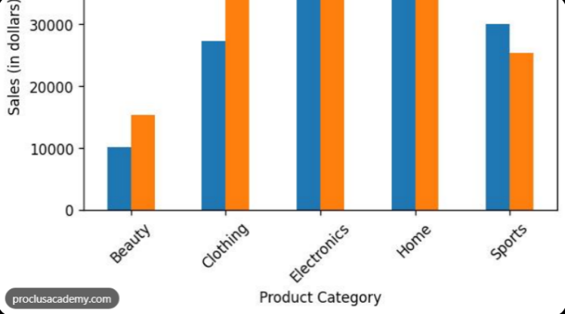

products = ["Laptop", "Phone", "Tablet", "Watch"]
revenue = [50000, 80000, 30000, 20000]

plt.figure(figsize=(8, 4))
plt.bar(products, revenue)
plt.title("Revenue by Product")
plt.xlabel("Product")
plt.ylabel("Revenue (₹)")
plt.grid(axis="y", alpha=0.3)
plt.tight_layout()
plt.show()

What each line does
- plt.figure(figsize=(8, 4)): sets the chart size in inches.
- plt.bar(products, revenue): creates the bars.
- plt.title(): adds a descriptive title.
- plt.xlabel() and plt.ylabel(): label the axes.
- plt.grid(axis="y", alpha=0.3): adds subtle horizontal reference lines.
- plt.tight_layout(): adjusts spacing.
- plt.show(): displays the figure.

Business observation: Phones generate the highest revenue among these four products, while watches generate the lowest.

Bar chart versus histogram
- A bar chart compares categories; bars may be arranged by value or a meaningful category order.
- A histogram shows the frequency distribution of numerical data grouped into intervals. Adjacent bins typically touch because the intervals represent a continuous numerical range.
Don't confuse them just because both contain rectangles.

line chart:
A line chart displays change over an ordered dimension, most commonly time.
Business use cases: monthly sales, daily website traffic, revenue growth or inventory levels.
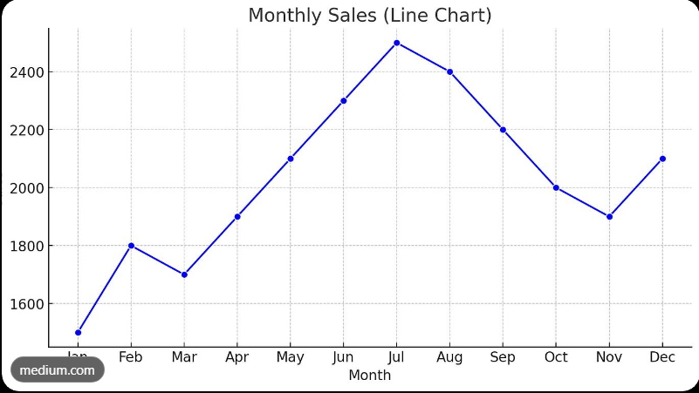
months = ["Jan", "Feb", "Mar", "Apr", "May", "Jun"]
monthly_sales = [20000, 24000, 22000, 30000, 35000, 40000]

plt.figure(figsize=(8, 4))

plt.plot(
months,
monthly_sales,
marker="o",
label="Sales"
)

plt.title("Monthly Sales Trend")
plt.xlabel("Month")
plt.ylabel("Sales (₹)")
plt.legend()
plt.grid(alpha=0.3)
plt.tight_layout()
plt.show()
The marker="o" argument marks each observation, while label="Sales" gives the series a name for the legend.
Business observation: Sales increase overall from January to June, with a temporary decline in March.
  - Create histograms and box plots:
Histogram
A histogram displays the distribution of a numerical variable by grouping values into bins.
Business use cases: customer spending, delivery duration, employee salaries, test scores and transaction amounts.
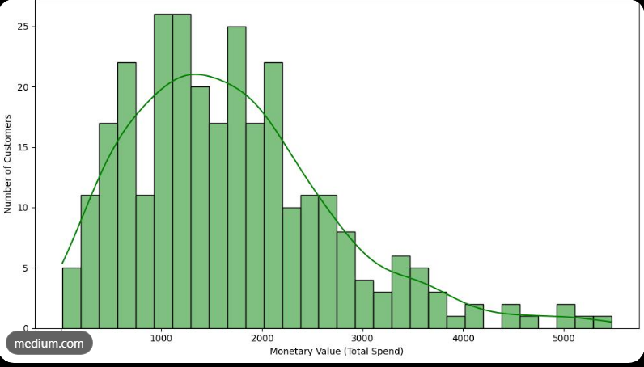
customer_spending = [
200, 250, 300, 320, 350,
400, 420, 450, 500, 550,
600, 700, 850, 1200, 3000
]
plt.figure(figsize=(8, 4))
plt.hist(customer_spending, bins=6, edgecolor="black")
plt.title("Distribution of Customer Spending")
plt.xlabel("Spending (₹)")
plt.ylabel("Number of customers")
plt.tight_layout()
plt.show()
Business observation: Most customers spend relatively modest amounts, while a small number spend considerably more. This suggests a right-skewed distribution worth investigating.
How the number of bins affects a histogram
- Too few bins can hide meaningful patterns.
- Too many bins can create a noisy, fragmented view.
- The appropriate number depends on sample size, the distribution and the analytical question.
Try changing bins=6 to bins=10 and compare the chart.
Box plot
A box plot summarises a numerical distribution using quartiles, a median and whiskers. It is useful for comparing distributions across groups and identifying potential outliers.
plt.figure(figsize=(7, 4))
plt.boxplot(order_values)
plt.title("Box Plot of Order Values")
plt.ylabel("Order value (₹ hundreds)")
plt.xticks([1], ["Orders"])
plt.grid(axis="y", alpha=0.3)
plt.tight_layout()
plt.show()

How to interpret a standard Matplotlib box plot
- The bottom of the box represents Q1.
- The line inside the box represents the median.
- The top of the box represents Q3.
- The box covers the middle 50% of the data.
- The whiskers extend to the most extreme observations within the usual 1.5-IQR fences.
- Observations beyond the whiskers are plotted individually as potential outliers.
The whiskers do not necessarily extend to the minimum and maximum values. Exact conventions can vary across plotting options and libraries.
Business observation: The unusually large order is separated from the main cluster of orders. Check whether it is a legitimate bulk transaction before deciding how it should affect business reporting.

  - Create scatter plots:
Scatter plot
A scatter plot represents the relationship between two numerical variables, with each point corresponding to an observation.
Business use cases: advertising spend versus sales, discount versus quantity sold, delivery distance versus delivery time, or website visits versus conversions.
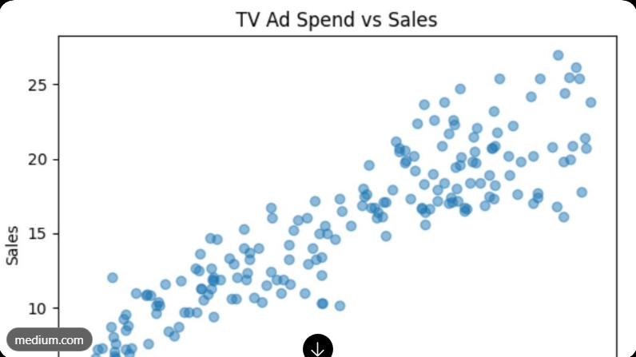

advertising_spend = [10, 20, 30, 40, 50, 60]
sales_revenue = [15, 22, 28, 39, 45, 58]
plt.figure(figsize=(8, 4))
plt.scatter(advertising_spend, sales_revenue, label="Observations")
plt.title("Advertising Spend vs Sales")
plt.xlabel("Advertising spend (₹ thousands)")
plt.ylabel("Sales (₹ thousands)")
plt.legend()
plt.grid(alpha=0.3)
plt.tight_layout()
plt.show()

Business observation: Sales generally increase as advertising spend increases in this illustrative dataset, indicating a positive association.

  - Build a correlation heatmap:

What is Seaborn?
Seaborn is a Python visualization library built on Matplotlib. It offers convenient functions for exploring distributions, relationships and grouped data, with sensible statistical defaults.

Matplotlib | Seaborn
Offers detailed control over individual chart elements | Provides convenient high-level statistical plots
Often needs more code for statistical plots | Often needs less code for statistical plots
Useful for custom chart construction | Useful for rapid statistical exploration and comparisons
Uses plt.bar(), plt.plot(), plt.scatter() and more | Uses sns.barplot(), sns.histplot(), sns.boxplot() and more

They work together; learning Seaborn does not mean abandoning Matplotlib.

A correlation heatmap is a colour-coded matrix showing pairwise correlation coefficients among numerical variables.

It is especially useful when a dataset contains many numerical columns and you want to identify possible relationships for further investigation.

numeric_data = pd.DataFrame({
"advertising_spend": [10, 20, 30, 40, 50, 60],
"sales": [15, 22, 28, 39, 45, 58],
"website_visits": [100, 150, 210, 260, 330, 400],
"returns": [8, 9, 12, 14, 16, 19]
})
correlation_matrix = numeric_data.corr(numeric_only=True)
plt.figure(figsize=(8, 5))
sns.heatmap(
correlation_matrix,
annot=True,
cmap="coolwarm",
vmin=-1,
vmax=1,
fmt=".2f")
plt.title("Correlation Heatmap")
plt.tight_layout()
plt.show()
Understand the arguments
- numeric_only=True: computes correlations for numerical columns.
- annot=True: writes each coefficient in its cell.
- cmap="coolwarm": uses contrasting colours for negative and positive values.
- vmin=-1, vmax=1: fixes the colour scale to the possible Pearson correlation range.
- fmt=".2f": formats annotations to two decimal places.
Business observation: Strong positive correlations between advertising spend, sales and website visits would suggest these variables move together in this dataset. That is a reason to investigate their relationships, not proof that one causes another.

Heatmap interpretation checklist
- Find coefficients close to +1 or −1.
- Check whether the relationship makes business sense.
- Investigate outliers and nonlinear patterns.
- Check whether variables are duplicates or mathematically related.
- Remember that correlation alone does not establish causation.
A heatmap summarizes relationships; it does not explain their causes.

Learning outcome:

- Create a Matplotlib bar chart and line chart.
- Create a histogram and box plot.
- Create a scatter plot and interpret its relationship.
- Create a Seaborn correlation heatmap.
- Customise chart titles, labels, legends, units and scales.
- Write one evidence-based business observation for every chart.

DAY 12 — Excel and Power BI Fundamentals

Task: Learn spreadsheet analysis and interactive dashboard development.

1. Practice Excel sorting, filtering, formulas, and PivotTables.
2. Import data into Power BI.
3. Use Power Query for basic data transformation.
4. Learn relationships and basic DAX measures.
5. Create KPI cards, bar charts, and trend charts.
6. Add slicers to filter the report.

  - Practice Excel sorting, filtering, formulas, and PivotTables.

Sorting data
Definition: Sorting arranges rows in a particular order based on one or more columns.
Common sorting methods:

- Ascending: A to Z, smallest to largest, oldest to newest.
- Descending: Z to A, largest to smallest, newest to oldest.
- Multi-level sorting: Sort by Region first, then Sales within each region.

Practical example: A sales manager wants to identify the highest-value orders.
Steps:
- Select a cell inside your dataset.
- Open the Data tab.
- Select Sort.
- Choose the Sales column.
- Select Largest to Smallest.
- Confirm that each order's information stays together.

3.2 Filtering data
Definition: Filtering temporarily displays only records that satisfy specified conditions without deleting the remaining records.

Examples:
Business question | Filter condition
Show only West region sales | Region = West
Show orders above ₹30,000 | Sales > 30000
Show electronics orders | Category = Electronics
Show orders from February | Date falls within February 2026
Find Laptop sales in the South | Region = South AND Product = Laptop

Steps:
- Click inside the Excel Table.
- Open the filter dropdown in the desired column.
- Select or search for the required values.
- Apply number, text, or date filters as appropriate.
- Clear the filter to return to the full dataset.

Remember: When multiple column filters are applied, Excel normally shows records satisfying all the active filters together.

Sorting vs filtering
Sorting | Filtering
Changes the display order | Hides records that do not match
All records generally remain visible | Only matching records are visible
Helps identify highest/lowest values | Helps isolate a specific subset

4. Excel formulas
A formula begins with =.

4.1 Essential formulas
Formula | Purpose | Example
SUM | Adds values | =SUM(F2:F11)
AVERAGE | Calculates arithmetic mean | =AVERAGE(F2:F11)
MIN | Finds smallest value | =MIN(F2:F11)
MAX | Finds largest value | =MAX(F2:F11)
COUNT | Counts numeric cells | =COUNT(F2:F11)
COUNTA | Counts non-empty cells | =COUNTA(A2:A11)
COUNTIF | Counts matching records | =COUNTIF(C2:C11,"West")
SUMIF | Sums values matching one condition | =SUMIF(C2:C11,"West",F2:F11)
SUMIFS | Sums using multiple conditions | =SUMIFS(F2:F11,C2:C11,"West",E2:E11,"Electronics")
IF | Returns a result based on a condition | =IF(F2>=30000,"High","Low")
IFERROR | Handles formula errors | =IFERROR(F2/G2,0)
ROUND | Rounds a number | =ROUND(F2/G2,2)

4.2 Practical formula exercises

Exercise A — Total sales
=SUM(F2:F11)

Exercise B — Average order-line sales
=AVERAGE(F2:F11)

Exercise C — Highest order-line sales
=MAX(F2:F11)

Exercise D — Number of orders in the West
=COUNTIF(C2:C11,"West")

Exercise E — Total sales in the West
=SUMIF(C2:C11,"West",F2:F11)

Exercise F — Calculate total cost
Add a new column called TotalCost in I1. In I2, enter:
=G2*H2

Exercise G — Calculate profit
Add a Profit column in J1. In J2, enter:
=F2-I2

4.3 Relative, absolute, and mixed cell references
Understanding cell references prevents many spreadsheet mistakes.
- Relative reference: A2 changes when a formula is copied.
- Absolute reference: $A$2 stays fixed when copied.
- Mixed reference: $A2 locks the column; A$2 locks the row.

Example: Suppose cell L1 contains a tax rate of 18%. To calculate tax on sales in F2, use:
=F2*$L$1

4.4 Additional formulas worth learning

- SUMPRODUCT — calculates products across corresponding ranges and sums them; useful for weighted calculations.
- IF with AND or OR — evaluates multiple logical conditions.
- XLOOKUP — retrieves matching information from another table.
- LEFT, RIGHT, MID, TRIM — manipulate and clean text.
- IFERROR — handles expected calculation errors without displaying raw error messages.
- DATE, YEAR, MONTH, TEXT — extract or format date-related information.
- SUBTOTAL — performs calculations such as sum or average while respecting filtered lists for supported operations.
Do not try to memorize every function today. Practise SUM, COUNTIF, SUMIF, SUMIFS, IF, and IFERROR first.

PivotTables — summarize thousands of records quickly
Definition: A PivotTable is an interactive Excel tool that summarizes data by categories, using calculations such as Sum, Count, Average, Minimum, and Maximum.
Imagine receiving 50,000 sales rows. Instead of writing a separate formula for every region and product, you can summarize the entire dataset in a few clicks.

Rows Region
Creates one summary row per region.
ValuesSales → Sum of Sales
Calculates total sales for each region.
FiltersCategory
Allows the summary to be restricted to a selected category.
ColumnsCategory
Separates the summary into columns for each category.

You do not need to use all four areas in every PivotTable. Start with Region in Rows and Sales in Values.

Excel may automatically choose Count instead of Sum if the source column contains text or inconsistent data types. Open Value Field Settings and choose the intended calculation. Fix the underlying data type as well.

5.4 Refresh and interact with PivotTables
- Refresh: Updates the PivotTable after source data changes.
- Slicer: Adds a clickable filter for fields such as Region or Category.
- Timeline: Provides a date-based filtering control where supported.
- Group dates: Groups individual dates into months, quarters, or years.
- Show Values As: Displays percentages of grand total, running totals, or other supported calculations.
Analyst warning: A PivotTable is not automatically refreshed whenever source values change. Refresh it, or configure the relevant refresh options, before reporting results.

5.1 Create your first PivotTable
- Click inside your Excel Table.
- Select Insert → PivotTable.
- Choose the table or range as the source.
- Place the PivotTable in a new worksheet.
- Drag fields into the following areas:

  - Import data into Power BI:
Power BI Desktop is commonly used to develop data models and reports. Its Windows desktop application is separate from Excel.

6.1 Import your sales CSV
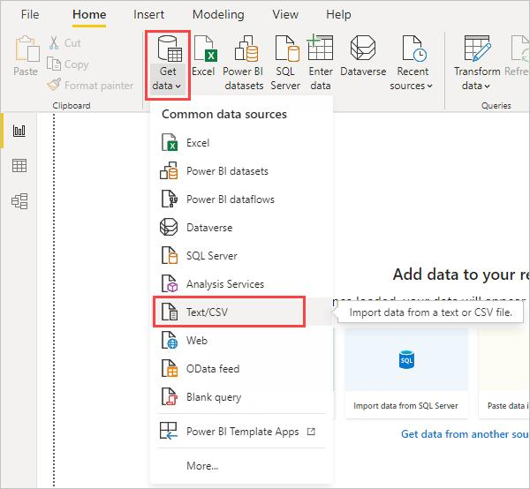
Step 1 — Get data
Open Power BI Desktop. Choose Home → Get data → Text/CSV and select sales_data.csv.
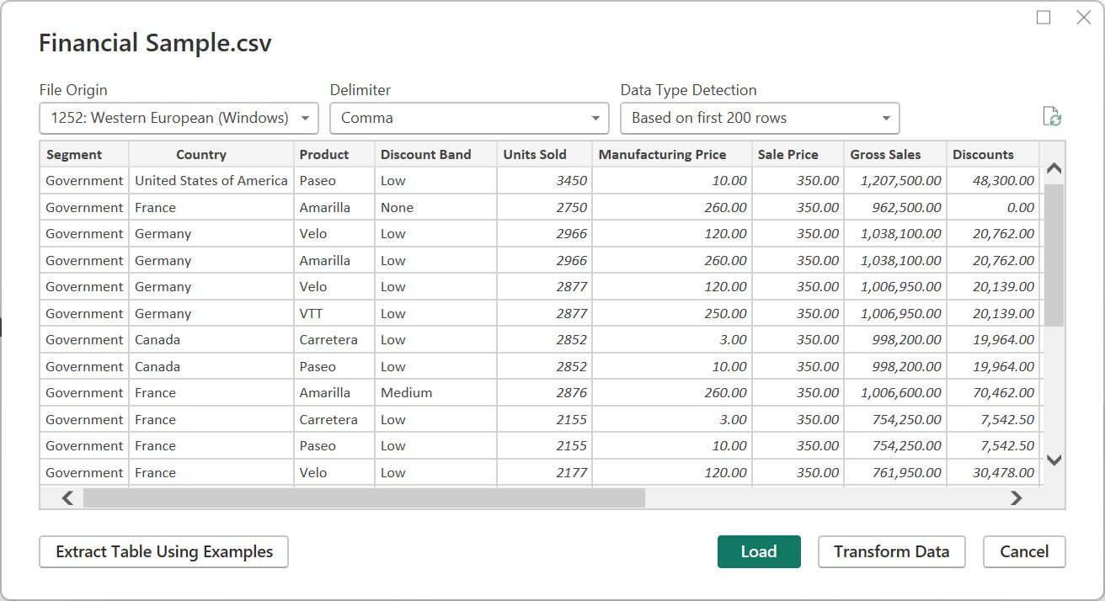
Step 2 — Preview
Check the delimiter, headers, and column values. Choose Transform Data to clean the data before loading it.
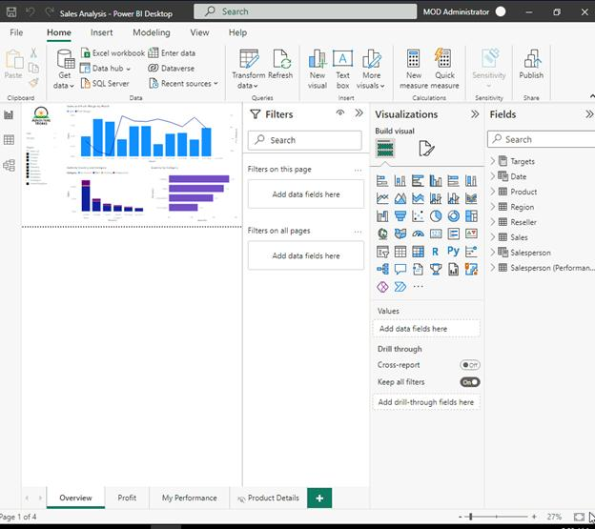
Step 3 — Load
After validating the data in Power Query, select Close & Apply. Power BI loads the prepared table into the model.
You can also import an Excel workbook using Home → Get data → Excel workbook.

6.2 Learn the three important Power BI views
View | What you do there
Report view | Build visuals, cards, charts, and slicers
Table/Data view | Inspect loaded rows and columns
Model view | Create and inspect relationships between tables
Interface labels may vary slightly between Power BI versions.
  - Use Power Query for basic data transformation:
Power Query is an ETL tool. ETL stands for Extract, Transform, Load.
- Extract: Bring data from a source.
- Transform: Clean, restructure, and validate it.
- Load: Send the prepared data into the destination, such as a Power BI data model.
In Power BI, choose Transform Data to open Power Query Editor.

Important Power Query operations

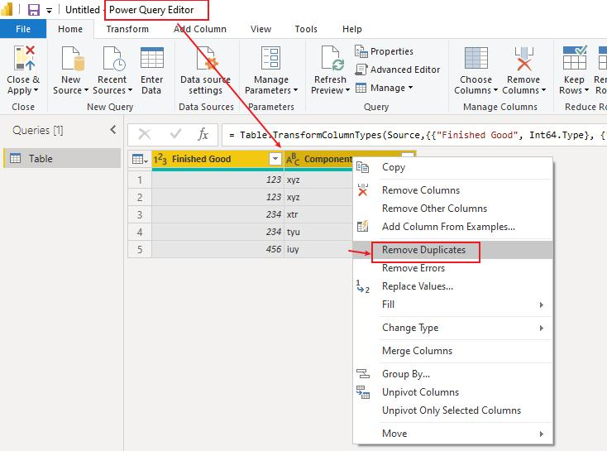
1. Remove duplicates
Select the appropriate column or columns and choose Remove Duplicates.
Analyst example: Remove duplicate customer records using a reliable customer ID. Do not blindly remove rows just because some values match.
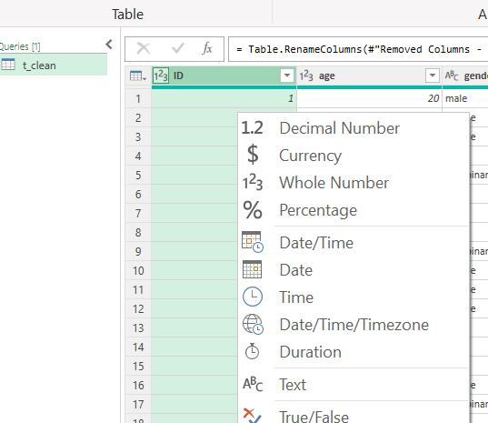
2. Change data types
Set Date to Date, Sales to a numeric type, Quantity to Whole Number, and product or region names to Text.
Why it matters: A date stored as text may not sort or group correctly, and text-formatted sales may not aggregate as expected.
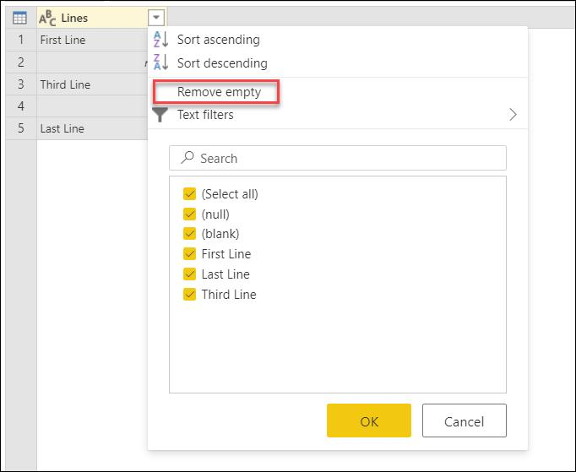
3. Handle missing values
Identify blank cells and determine whether to replace, retain, or exclude them based on the business meaning.
Example: A missing sales value is not necessarily zero. Zero means confirmed no sales; blank may mean unknown.
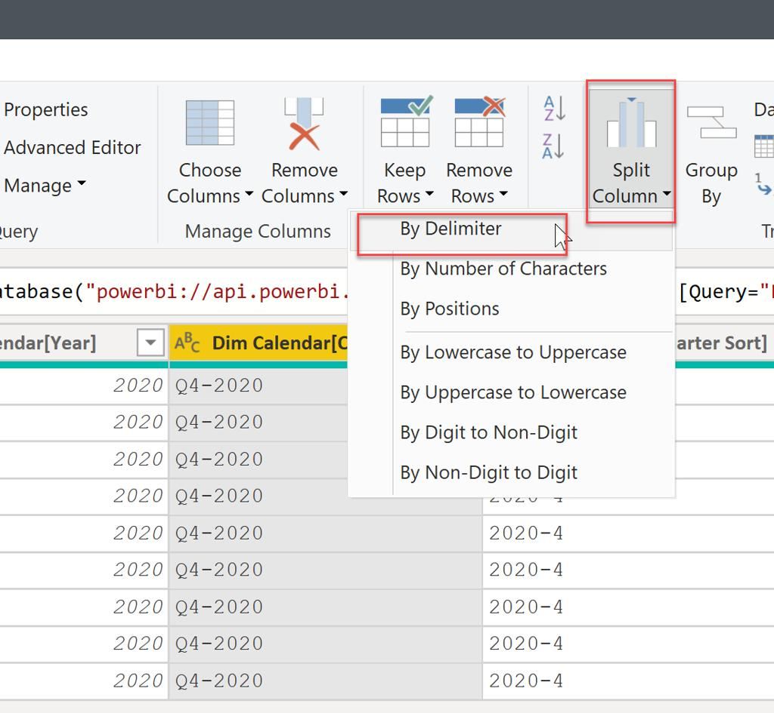
4. Split and merge columns
Split a full name into first and last names, or merge address components. Choose a suitable delimiter, such as a comma or space.
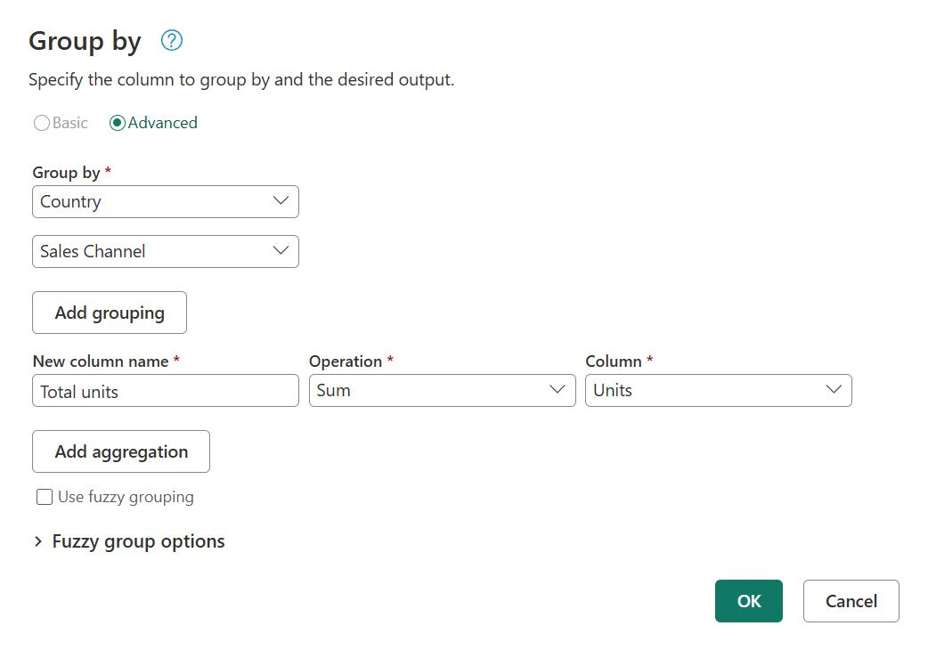
5. Group By
Summarize rows by a category and calculate sum, count, average, minimum, or maximum.
Example: Group by Region and calculate the sum of Sales. This is a data transformation, whereas a PivotTable or report visual summarizes data for analysis.

  - Learn relationships and basic DAX measures:

Understand primary keys and foreign keys:
A primary key uniquely identifies a record in a table.
A foreign key references a key in another table.

A one-to-many relationship. One region can be associated with many sales records.

In Model view, drag Regions[RegionID] onto Sales[RegionID], or create the relationship through Manage Relationships.

Configure the relationship as:
- Cardinality: One-to-many (1:*)
- One side: Regions
- Many side: Sales
- Cross-filter direction: Single, in the normal dimension-to-fact direction
Power BI may detect the relationship automatically, but you must verify it.

Why relationships matter
Suppose you build a chart using Regions[Region] on the axis and a Sales measure as the value. The relationship allows each region to filter the relevant rows in Sales.
Without a valid relationship, your visuals may show repeated totals, blank categories, or misleading results.

star schema
A star schema is a common analytical data model in which a central fact table connects to descriptive dimension tables.

Conceptually, the dimension tables describe what, where, and when, while the fact table records measurable business events.
For a real sales report, you would commonly have:
- FactSales: sales transactions and numeric measures.
- DimProduct: product names, categories, and product attributes.
- DimRegion: region attributes.
- DimDate: dates, months, quarters, and years.
Important: A date dimension should generally contain one row per date and a unique date key. It enables consistent date filtering and time intelligence.

DAX — calculations in Power BI
DAX stands for Data Analysis Expressions. It is the formula language used by Power BI for measures, calculated columns, and calculated tables.
Excel formulas calculate values in a spreadsheet. DAX calculations operate within the Power BI data model and respond to report filters and relationships.
9.1 Measures vs calculated columns

Feature | Measure | Calculated column
When calculated | When evaluated in a query or visual | For each row during model processing
Stored per row | No, generally not | Yes
Responds to slicers | Yes, through filter context | The stored column values themselves do not recalculate from slicers
Typical use | Total sales, profit margin, average order value | Row-level categories, flags, derived attributes
Example | Total Sales = SUM(Sales[Sales]) | Sales[Profit] = Sales[Sales] - Sales[TotalCost]

Best practice: Use measures for business KPIs and aggregated values. Use calculated columns when you need a row-level value that can be grouped, filtered, or used in relationships.

In Power BI Desktop:
- Select the Sales table in the Data or Model pane.
- Choose New measure.
- Enter a DAX expression in the formula bar.

Measure 1 — Total Sales
Total Sales = SUM(Sales[Sales])
Expected result with no filters: ₹266,900.

Measure 2 — Total Quantity
Total Quantity = SUM(Sales[Quantity])
Expected result: 33 units.

Measure 3 — Total Cost
Total Cost =
SUMX(
Sales,
Sales[Quantity] * Sales[UnitCost]
)
Expected result: ₹204,340.
SUMX iterates through the Sales table, evaluates the expression for each row, and adds the results.

Measure 4 — Total Profit
Total Profit = [Total Sales] - [Total Cost]
Expected result: ₹62,560.

Measure 5 — Profit Margin
Profit Margin =
DIVIDE(
[Total Profit],
[Total Sales],
0
)
Expected result: approximately 23.44%.

Measure 6 — Order Count
Order Count = DISTINCTCOUNT(Sales[OrderID])
Expected result: 10.
DISTINCTCOUNT counts unique IDs. This is different from counting rows if the same order can appear on multiple rows.

DIVIDE is safer than directly dividing two expressions when the denominator could be zero. The third argument specifies what to return if division is invalid due to a zero denominator.
Format this measure as Percentage in the measure's formatting settings.

- CALCULATE() evaluates an expression under a modified filter context.
- FILTER() returns a filtered table.
- AVERAGE() calculates the average of a numeric column.
- COUNTROWS() counts rows in a table.
- RELATED() retrieves a related value from another table when the relationship permits it.
- ALL() can remove filters from a table or column in an expression.
- DIVIDE() handles division more safely.

  - Create KPI cards, bar charts, and trend charts:

KPI card:
A Key Performance Indicator (KPI) is a metric used to monitor progress toward a business objective. A Card visual can display a single important measure.

Create a Card in Power BI:
- Open Report view.
- Select a Card visual.
- Drag the Total Sales measure into the card's data field.
- Format the number and currency display.
- Repeat for Total Profit, Order Count, and Profit Margin.
A KPI value alone does not show whether performance is good or bad. In a real business report, compare it with a target, prior period, or budget when those data are available.

10.2 Bar chart — compare sales by region
Business question: Which region generates the most sales?
Steps:
- Insert a clustered bar chart.
- Add Region to the Y-axis/category field.
- Add [Total Sales] to the X-axis/value field.
- Sort by Total Sales in descending order.
- Turn on data labels if they improve readability.
Expected ranking:
- West — ₹117,000
- South — ₹93,900
- North — ₹33,000
- East — ₹23,000
A bar chart works well for comparing discrete categories. It makes the gap between regions easier to interpret than a list of numbers.

10.3 Line chart — analyze sales trends
Business question: How did sales change over time?
For this dataset, monthly sales are:
Month | Total Sales
January 2026 | ₹64,500
February 2026 | ₹50,400
March 2026 | ₹152,000
Total | ₹266,900
Steps:
- Insert a Line chart.
- Add Date to the X-axis.
- Add [Total Sales] to the Y-axis.
- Use the date hierarchy or a proper month field to aggregate by month.
- Ensure the months appear in chronological order.
Interpretation: Sales decreased in February and increased sharply in March. However, three months of fictional data are insufficient to establish a long-term trend or explain the reason for the increase.

10.4 Choose the right visual
Visual | Best suited for
Card | One key number
Bar chart | Comparing regions or products
Column chart | Comparing categories vertically
Line chart | Trends over time
Table | Detailed records
Matrix | Grouped summaries with rows and columns
Pie/donut chart | A small number of meaningful parts of a whole
Scatter chart | Relationship between two numeric variables

Analyst tip: Avoid using a pie chart for many categories, a line chart for unordered categories, or a 3D chart that distorts comparisons.

  - Add slicers to filter the report:
A slicer is a visual filter that allows report users to select values directly.
For the sample dashboard, create three slicers:
- Region
- Category
- Date

Practical steps
- Select the Slicer visual.
- Add Region to the slicer's field.
- Repeat with Category.
- Add a Date slicer, using a date range or suitable date hierarchy.
- Select West and observe the cards and charts.
- Clear the selection and verify that the original totals return.

A correctly configured slicer should change the relevant visuals automatically.
What happens when multiple slicers are selected?
Suppose you choose:
- Region = West
- Product = Laptop
The filtered sales total is ₹90,000, because only the West Laptop records contribute to that selection.
This is an example of interactive analysis: a manager can investigate a specific segment without manually editing the underlying data.
Additional concepts
- Cross-filtering: Selecting a chart element filters other visuals.
- Cross-highlighting: Selecting a chart element highlights the related contribution in other visuals.
- Edit interactions: Lets you decide which visuals a slicer or chart selection affects.
- Sync slicers: Allows compatible slicers to share selections across report pages.
- Reset filters: Gives users a way to return to the default report state.
Test these interactions before sharing a report. Not every visual necessarily interacts with every other visual in the same way.

Recommended page layout
- Top: Report title and reporting period.
- First row: KPI cards for Total Sales, Total Profit, Order Count, and Profit Margin.
- Middle: Bar chart for sales by region and line chart for monthly sales.
- Bottom: Product-level summary table or chart.
- Side or top: Region, Category, and Date slicers.

Dashboard design rules
- Use descriptive titles such as Sales by Region instead of Chart 1.
- Format money consistently and use percentages for ratios.
- Use the same color for the same metric across visuals.
- Avoid unnecessary decoration, too many colors, and excessive gridlines.
- Keep the most important KPIs visible without scrolling.
- Include units, date ranges, and relevant context.
- Check that all filters work and all totals reconcile.

DAY 13 — Exploratory Data Analysis and Business Questions

Date:-27/10/2026

Task: Learn to convert business problems into analytical questions.

1. Select a sample sales or customer dataset.
2. Define five business questions.
3. Identify the metrics needed to answer each question.
4. Use Pandas, SQL, and visualizations to analyze the data.
5. Record the findings and any limitations.

  - Select a sample sales or customer dataset:
We will use a small fictional sales dataset. The same analytical approach works for larger datasets from real companies.
OrderID | Date | Product | Region | Quantity | UnitPrice | UnitCost
O101 | 2026-01-05 | Laptop | West | 2 | 50000 | 40000
O102 | 2026-01-12 | Phone | East | 3 | 20000 | 15000
O103 | 2026-01-20 | Laptop | West | 1 | 50000 | 40000
O104 | 2026-02-03 | Headphones | North | 5 | 3000 | 1800
O105 | 2026-02-14 | Phone | West | 2 | 20000 | 15000
O106 | 2026-02-22 | Laptop | South | 1 | 50000 | 40000
O107 | 2026-03-02 | Phone | East | 4 | 20000 | 15000
O108 | 2026-03-10 | Headphones | West | 10 | 3000 | 1800
O109 | 2026-03-18 | Laptop | North | 2 | 50000 | 40000
O110 | 2026-03-25 | Phone | West | 1 | 20000 | 15000
Important: This dataset contains one row per order and assumes each order contains one product. In a real dataset, an order can contain multiple products and may need a separate order-details table.
Create the dataset in Python
import pandas as pd

data = {
"OrderID": [
"O101", "O102", "O103", "O104", "O105",
"O106", "O107", "O108", "O109", "O110"
],
"Date": [
"2026-01-05", "2026-01-12", "2026-01-20",
"2026-02-03", "2026-02-14", "2026-02-22",
"2026-03-02", "2026-03-10", "2026-03-18",
"2026-03-25"
],
"Product": [
"Laptop", "Phone", "Laptop", "Headphones", "Phone",
"Laptop", "Phone", "Headphones", "Laptop", "Phone"
],
"Region": [
"West", "East", "West", "North", "West",
"South", "East", "West", "North", "West"
],
"Quantity": [2, 3, 1, 5, 2, 1, 4, 10, 2, 1],
"UnitPrice": [50000, 20000, 50000, 3000, 20000,
50000, 20000, 3000, 50000, 20000],
"UnitCost": [40000, 15000, 40000, 1800, 15000,
40000, 15000, 1800, 40000, 15000]
}

df = pd.DataFrame(data)
df["Date"] = pd.to_datetime(df["Date"])

df["Sales"] = df["Quantity"] * df["UnitPrice"]
df["Cost"] = df["Quantity"] * df["UnitCost"]
df["Profit"] = df["Sales"] - df["Cost"]

print(df.head())

  - Define five business questions:
A good business question should be specific, answerable with available data, and connected to a business decision.
No. | Business question | Metrics required | Useful dimension | Visualization
1 | Which products generate the most sales and profit? | Total sales, total profit, units sold | Product | Bar chart
2 | Which region performs best? | Sales, profit, profit margin | Region | Bar chart
3 | How do sales change month by month? | Monthly sales, monthly profit | Month | Line chart
4 | Which products have the highest profit margin? | Sales, cost, profit margin | Product | Bar chart
5 | Are there data-quality problems that could affect decisions? | Missing values, duplicates, invalid quantities, unusual values | Columns and records | Data-quality summary

  - Identify the metrics needed to answer each question:

Question 1 — Which products generate the most sales and profit?
Business thinking
The business wants to know which products contribute most to revenue and profit so it can make informed inventory, marketing, and pricing decisions.
Metrics:
- Total Sales = Quantity × UnitPrice, summed across orders.
- Total Profit = Total Sales − Total Cost.
- Units Sold = Sum of Quantity.
Pandas analysis
product_summary = (
df.groupby("Product")
.agg(
Total_Sales=("Sales", "sum"),
Total_Profit=("Profit", "sum"),
Units_Sold=("Quantity", "sum")
)
.sort_values("Total_Sales", ascending=False)
)
print(product_summary)

SQL analysis
Assume the dataset is stored in a table named sales.
SELECT
Product,
SUM(Quantity * UnitPrice) AS Total_Sales,
SUM(Quantity * (UnitPrice - UnitCost)) AS Total_Profit,
SUM(Quantity) AS Units_Sold
FROM sales
GROUP BY Product
ORDER BY Total_Sales DESC;
Findings
Product | Total sales | Total profit | Units sold
Laptop | ₹3,00,000 | ₹60,000 | 6
Phone | ₹2,00,000 | ₹50,000 | 10
Headphones | ₹45,000 | ₹18,000 | 15
Interpretation: Laptops generate the highest revenue and total profit in this sample. Headphones generate the lowest total revenue, but sell the highest number of units.
Possible business action: Review product demand, inventory requirements, and profit contribution together instead of ranking products by revenue alone.

Question 2 — Which region performs best?
Business thinking
The business wants to compare regional performance and identify where sales and profits are strongest.
Metrics:
- Total Sales
- Total Profit
- Profit Margin = Total Profit ÷ Total Sales × 100
Pandas analysis
region_summary = (
df.groupby("Region")
.agg(
Total_Sales=("Sales", "sum"),
Total_Profit=("Profit", "sum")
))region_summary["Profit_Margin"] = (
region_summary["Total_Profit"]
/ region_summary["Total_Sales"] * 100)
print(region_summary.sort_values("Total_Sales", ascending=False))

SQL analysis
SELECT
Region,
SUM(Quantity * UnitPrice) AS Total_Sales,
SUM(Quantity * (UnitPrice - UnitCost)) AS Total_Profit,
100.0 * SUM(Quantity * (UnitPrice - UnitCost))
/ NULLIF(SUM(Quantity * UnitPrice), 0) AS Profit_Margin
FROM sales
GROUP BY Region
ORDER BY Total_Sales DESC;
NULLIF(..., 0) prevents division by zero if total sales are zero.

Findings
Region | Total sales | Total profit | Profit margin
West | ₹2,40,000 | ₹57,000 | 23.75%
East | ₹1,40,000 | ₹35,000 | 25.00%
North | ₹1,15,000 | ₹26,000 | 22.61%
South | ₹50,000 | ₹10,000 | 20.00%
Interpretation: West has the highest total sales and profit. East has the highest profit margin, meaning it retains a larger share of sales as product profit.
Possible business action: Investigate what contributes to West's overall performance and whether practices in East can be replicated elsewhere. Before making decisions, consider regional differences in product mix, customer demand, and operating expenses.

Question 3 — How do sales change month by month?
Business thinking
The business wants to identify sales trends and determine which months perform better or worse.
Metrics: Monthly sales and monthly profit.
Pandas analysis
monthly_summary = (
df.groupby(df["Date"].dt.to_period("M"))
.agg(
Total_Sales=("Sales", "sum"),
Total_Profit=("Profit", "sum")
))
print(monthly_summary)

SQL analysis
The following uses SQLite-style date functions:
SELECT
strftime('%Y-%m', Date) AS Sales_Month,
SUM(Quantity * UnitPrice) AS Total_Sales,
SUM(Quantity * (UnitPrice - UnitCost)) AS Total_Profit
FROM sales
GROUP BY strftime('%Y-%m', Date)
ORDER BY Sales_Month;

Findings
Month | Total sales | Total profit
January 2026 | ₹2,10,000 | ₹45,000
February 2026 | ₹1,05,000 | ₹26,000
March 2026 | ₹2,30,000 | ₹57,000
Interpretation: Sales declined in February and increased in March. March has the highest sales and profit in this sample.
Possible business action: Investigate whether the change was associated with promotions, product availability, customer demand, or other factors.
Important: Three months of data are not enough to establish a reliable seasonal pattern. A trend in this sample does not prove the same pattern will repeat.

Question 4 — Which products have the highest profit margin?

Business thinking
A product can generate high revenue but have a low profit margin. The business wants to know how much product profit it earns for each rupee of sales.
Formula:
$$\text{Profit Margin (\%)}=\frac{\text{Total Profit}}{\text{Total Sales}}×100$$Pandas analysis
margin_summary = (
df.groupby("Product")
.agg(
Total_Sales=("Sales", "sum"),
Total_Profit=("Profit", "sum")
)
)
margin_summary["Profit_Margin"] = (
margin_summary["Total_Profit"]
/ margin_summary["Total_Sales"] * 100
)
print(margin_summary.sort_values("Profit_Margin", ascending=False))

SQL analysis
SELECT
Product,
SUM(Quantity * UnitPrice) AS Total_Sales,
SUM(Quantity * (UnitPrice - UnitCost)) AS Total_Profit,
100.0 * SUM(Quantity * (UnitPrice - UnitCost))
/ NULLIF(SUM(Quantity * UnitPrice), 0) AS Profit_Margin
FROM sales
GROUP BY Product
ORDER BY Profit_Margin DESC;

Findings
Product | Total sales | Total profit | Profit margin
Headphones | ₹45,000 | ₹18,000 | 40%
Phone | ₹2,00,000 | ₹50,000 | 25%
Laptop | ₹3,00,000 | ₹60,000 | 20%
Interpretation: Headphones have the highest product profit margin, at 40%, while laptops have the highest total profit but the lowest margin, at 20%.
Possible business action: Compare margins alongside sales volume, customer demand, and inventory costs before changing pricing or promotional strategies.
Note that these margins use only the product costs provided. They are not net profit margins because other expenses are excluded.

Question 5 — Are there data-quality problems?
EDA should not begin and end with business metrics. An analyst must also check whether the underlying data is trustworthy.
Pandas data-quality checks
# 1. Dataset size
print("Rows and columns:", df.shape)

# 2. Missing values
print("\nMissing values:")
print(df.isnull().sum())

# 3. Duplicate records
print("\nDuplicate rows:", df.duplicated().sum())

# 4. Duplicate order IDs
print("Duplicate Order IDs:", df["OrderID"].duplicated().sum())

# 5. Invalid quantities or prices
print("Invalid quantities:", (df["Quantity"] <= 0).sum())
print("Invalid prices:", (df["UnitPrice"] < 0).sum())
print("Invalid costs:", (df["UnitCost"] < 0).sum())

# 6. Date range
print("Date range:", df["Date"].min(), "to", df["Date"].max())

# 7. Check whether cost exceeds price
print("Rows where cost exceeds price:",
(df["UnitCost"] > df["UnitPrice"]).sum())

What should the analyst look for?
- Missing values: Are product names, dates, quantities, or prices absent?
- Duplicates: Has an order been recorded more than once?
- Invalid values: Are quantities zero or negative when they should be positive?
- Inconsistent formats: Are dates stored in different formats?
- Unusual values: Are there unexpectedly large orders or prices?
- Business-rule violations: Does the cost exceed the selling price, and if so, is that valid for the business?
A cost greater than the selling price is not necessarily a data error; it may represent a genuine loss-making sale.
Findings for our sample
The provided sample has 10 rows, 10 distinct order IDs, and no deliberately introduced missing values or invalid quantities. This is useful for practicing, but it does not establish that real-world data would be equally clean.

  - Use Pandas, SQL, and visualizations to analyze the data:
Visualizations help communicate findings quickly. Choose the chart based on the question rather than choosing a chart first and trying to fit the data into it.
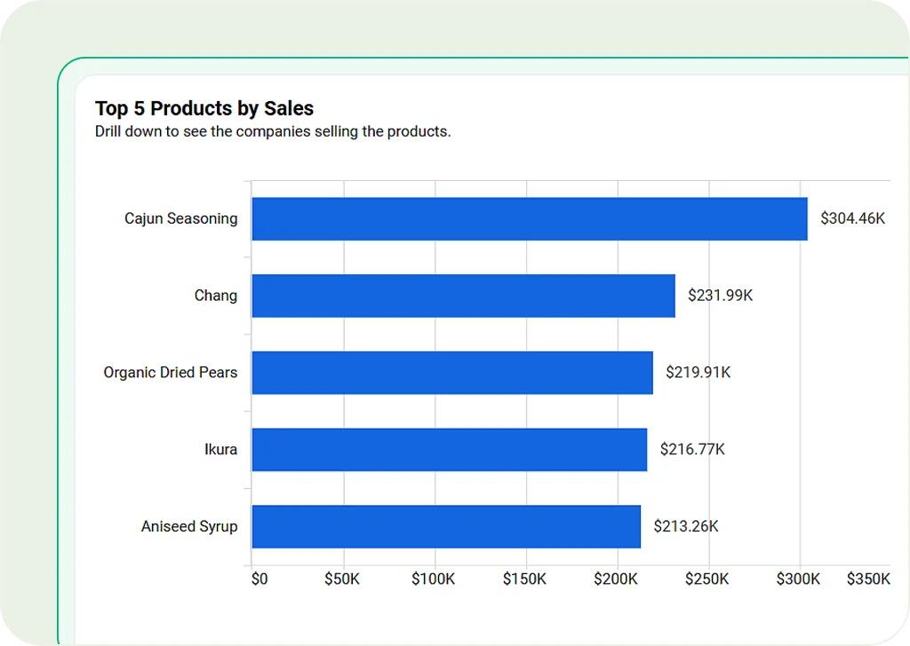
Bar chart — Compare products or regions
Best for comparing categories such as total sales by product or profit by region.
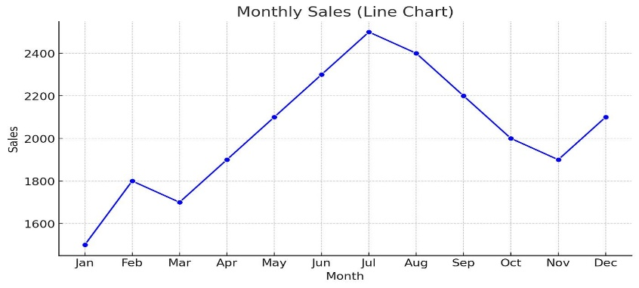
Line chart — Analyze trends over time
Best for identifying increases, decreases, and fluctuations in monthly sales.
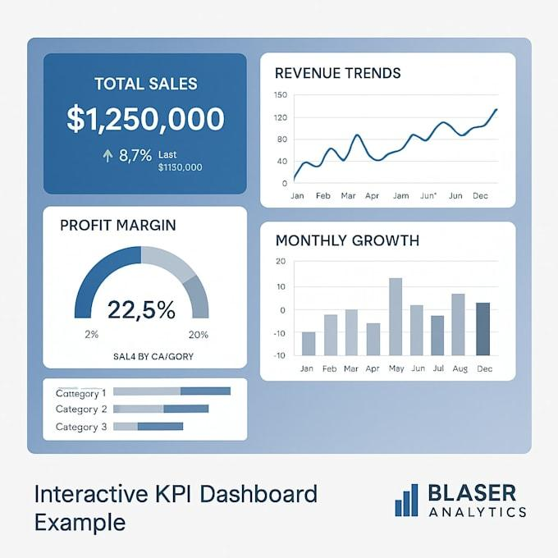
KPI cards — Display key metrics
Best for showing overall sales, total profit, order count, or profit margin.
Python code
Run this after creating df and calculating its Sales, Cost, and Profit columns.
import matplotlib.pyplot as plt
# Chart 1: Sales by product
product_sales = df.groupby("Product")["Sales"].sum()
product_sales.plot(kind="bar", title="Total Sales by Product")
plt.xlabel("Product")
plt.ylabel("Sales (₹)")
plt.xticks(rotation=0)
plt.tight_layout()
plt.show()
# Chart 2: Monthly sales trend
monthly_sales = (
df.groupby(df["Date"].dt.to_period("M"))["Sales"].sum()
)
monthly_sales.index = monthly_sales.index.astype(str)
monthly_sales.plot(
kind="line",
marker="o",
title="Monthly Sales Trend"
)
plt.xlabel("Month")
plt.ylabel("Sales (₹)")
plt.xticks(rotation=0)
plt.tight_layout()
plt.show()
SQL Query
import sqlite3
connection = sqlite3.connect("sales.db")
df.to_sql(
"sales",
connection,
if_exists="replace",
index=False
)

query = """
SELECT
Product,
SUM(Sales) AS Total_Sales,
SUM(Profit) AS Total_Profit
FROM sales
GROUP BY Product
ORDER BY Total_Sales DESC;
"""
result = pd.read_sql_query(query, connection)
print(result)
connection.close()
This allows you to practice SQL against the same dataset you used in Pandas. SQLite is convenient for local practice; other databases may use different date functions or data types.
  - Record the findings and any limitations:

1. Overall performance
- Total sales: ₹5,45,000
- Total product cost: ₹4,17,000
- Total product profit: ₹1,28,000
- Overall product profit margin: 23.49%
2. Main findings
- Laptops generated the highest total sales (₹3,00,000).
- The West region generated the highest total sales (₹2,40,000).
- March recorded the highest monthly sales (₹2,30,000).
- Headphones had the highest product profit margin (40%).
- February had the lowest sales among the three months analyzed.
3. Possible recommendations
- Review product demand and inventory before deciding how much stock to purchase.
- Investigate why February sales were lower than January and March.
- Compare regional sales and profit margins before allocating marketing resources.
- Evaluate product margins alongside sales volume and operating expenses.
4. Limitations
- The dataset contains only 10 fictional orders.
- The analysis covers only three months.
- Advertising, shipping, salaries, returns, discounts, and other expenses are not included.
- The dataset does not contain customer IDs, so customer retention and repeat purchasing cannot be evaluated.
- The findings show patterns in this sample; they do not establish why those patterns occurred.

Learning outcomes:
A data analyst does more than calculate numbers.
The job is to translate a business problem into clear questions, select appropriate metrics, analyze and validate data, explain the findings, and state the limitations honestly.

DAY-14 Machine Learning Fundamentals

Task: Understand the machine learning workflow.

1. Learn supervised and unsupervised learning.
2. Understand classification and regression.
3. Study training, validation, and testing datasets.
4. Learn overfitting and underfitting.
5. Understand accuracy, precision, recall, Fl-score, and MAE.
6. Train a simple model using Scikit-learn.

- Learn supervised and unsupervised learning:
Machine Learning (ML) is a branch of Artificial Intelligence (AI) that enables computers to learn patterns from data and use those patterns to make predictions or identify structure without explicitly programming every decision rule.
These are two fundamental categories of machine learning.

A. Supervised learning
Definition: Supervised learning uses labeled data, where the correct target or outcome is provided for training.
For example, a dataset may contain customer information alongside whether each customer previously left a service.
The model learns from these examples to predict the outcome for new customers.
Common uses:
- Predicting sales revenue
- Classifying emails as spam or not spam

B. Unsupervised learning
Definition: Unsupervised learning finds patterns or structure in data without a supplied target label.
For example, a store may group customers based on purchasing behavior without knowing their customer segments in advance.
Common uses:
- Customer segmentation
- Grouping similar products
- Finding unusual transactions
- Exploring hidden patterns in data

- Supervised learning
Learns from examples with known answers.
Example: past customer records labeled as churned or retained.
- Unsupervised learning
Discovers groups or structure without known target labels.
Example: grouping customers by similar purchasing behavior.

Comparison table
Property | Supervised | Unsupervised
Target labels | Available | Not supplied
Main goal | Predict a known outcome | Discover structure
Common tasks | Classification, regression | Clustering, dimensionality reduction
Example algorithm | Decision Tree | K-Means
Evaluation | Compare predictions with known answers | Evaluate grouping quality and usefulness

Other learning paradigms also exist, including reinforcement learning, where an agent learns through actions, rewards, and feedback.

- Understand classification and regression:

Classification and regression are the two main types of supervised learning. They differ primarily in the kind of target they predict.
A. Classification
Definition: Classification predicts a category or class.
Examples:
- Fraudulent or legitimate transaction
- Customer churn or no churn
- Spam or not spam
- Low, medium, or high customer risk
Classification can be binary (two classes) or multiclass (more than two classes).

B. Regression

Definition: Regression predicts a numerical quantity.
Examples:
- Monthly sales revenue
- House price
- Product demand
- Delivery time

Quick decision rule
- If the target is a category, consider classification.
- If the target is a numerical quantity, consider regression.
A numerical code does not automatically make a target a regression problem. For example, customer categories coded as 0, 1, and 2 are still classes if those numbers represent labels rather than quantities.

Understand features (X) and target (y)
Before training a model, identify what information it will learn from and what it must predict.

Suppose you have this dataset:
Advertising spend (₹) | Price (₹) | Sales (₹)
1,000 | 100 | 5,000
2,000 | 100 | 8,000
3,000 | 90 | 12,000

Here:
- Features (X): Advertising spend and price.
- Target (y): Sales.
- Model task: Predict sales from advertising spend and price.

In Pandas:
X = df[["AdvertisingSpend", "Price"]]
y = df["Sales"]

Notice the double brackets in df[["AdvertisingSpend", "Price"]]: they select two feature columns as a DataFrame. y = df["Sales"] selects a single target column as a Series.

- Study training, validation, and testing datasets:
A model must be evaluated on data it did not learn from. Otherwise, its performance may look better than it really is.

Training dataset
Used to fit the model and learn patterns.
Validation dataset
Used during model development to compare models, tune hyperparameters, and choose settings.
Testing dataset
Held aside for the final, relatively unbiased evaluation after model choices are complete.

Typical workflow
- Separate features and target.
- Split off the test dataset.
- Use the training data to fit candidate models.
- Use validation data or cross-validation to select the model and tune its settings.
- Evaluate the selected model on the test data once the choices are finalized.

For small beginner datasets, a simple train/test split is useful for practice. For more serious work, use enough data for reliable evaluation and consider cross-validation. For time-dependent data such as monthly sales, split chronologically rather than randomly, so the model does not learn from the future to predict the past.

Scikit-learn syntax

from sklearn.model_selection import train_test_split
X_train, X_test, y_train, y_test = train_test_split(
X, y,
test_size=0.2,
random_state=42
)

- test_size=0.2: reserves 20% for testing.
- random_state=42: makes the random split reproducible.
- X_train, y_train: training features and labels.
- X_test, y_test: held-out test features and labels.
This creates a training/test split, not a separate validation set. You can create a validation set from the remaining training portion when needed.

- Learn overfitting and underfitting:

Overfitting
Definition: Overfitting occurs when a model learns the training data too specifically, including noise or accidental patterns, and does not generalize well to new data.
Example: a complicated model memorizes past customer behavior but performs poorly on new customers.

Underfitting
Definition: Underfitting occurs when a model is too simple or insufficiently trained to capture the meaningful patterns in the data.
Example: using a straight-line model for a relationship that is strongly curved.

- Underfitting
The model misses important patterns.
Often high error on both training and validation data.

- Overfitting
The model follows noise or individual training examples too closely.
Training performance is strong, but validation performance is noticeably worse.

- Reasonable fit
The model captures useful patterns and generalizes to unseen data.

How to reduce these problems:

Problem | Potential solutions
Overfitting | Simplify the model, use regularization, obtain more representative data, or use cross-validation
Underfitting | Use more suitable features, a more expressive model, or better training settings

The goal is not to make training performance perfect. The goal is to achieve reliable performance on new data.

- Understand accuracy, precision, recall, Fl-score, and MAE:

Different metrics answer different questions. The correct metric depends on the business problem and the consequences of prediction errors.

A. Confusion matrix — classification
A confusion matrix compares actual classes with predicted classes.

 | Predicted positive | Predicted negative
Actually positive | True Positive (TP) | False Negative (FN)
Actually negative | False Positive (FP) | True Negative (TN)

Example: a model predicts whether a transaction is fraudulent.
- TP: A fraudulent transaction correctly flagged.
- FP: A legitimate transaction incorrectly flagged.
- FN: A fraudulent transaction missed by the model.
- TN: A legitimate transaction correctly left unflagged.

B. Accuracy
Definition: The proportion of all predictions that are correct.
$$\text{Accuracy}=\frac{TP+TN}{TP+TN+FP+FN}$$
Example: if a model correctly classifies 90 out of 100 transactions, its accuracy is 90%.
Limitation: Accuracy can be misleading when one class is much more common than the other.

If only 1% of transactions are fraudulent, a model that predicts “legitimate” for every transaction can reach 99% accuracy while detecting no fraud.

C. Precision
Definition: Of all cases predicted positive, what proportion were actually positive?
$$\text{Precision}=\frac{TP}{TP+FP}$$
High precision means fewer false alarms among positive predictions.
Example: useful when the business wants to minimize legitimate transactions being incorrectly flagged for investigation.

D. Recall
Definition: Of all actual positive cases, what proportion did the model identify?
$$\text{Recall}=\frac{TP}{TP+FN}$$High recall means fewer actual positive cases are missed.
Example: useful in fraud detection when missing fraudulent transactions is particularly costly.

E. F1-score
Definition: The harmonic mean of precision and recall.
$$F1=2×\frac{\text{Precision}×\text{Recall}}{\text{Precision}+\text{Recall}}$$F1 is useful when both precision and recall matter. It is not simply the arithmetic average of the two.

Interactive classification demonstration

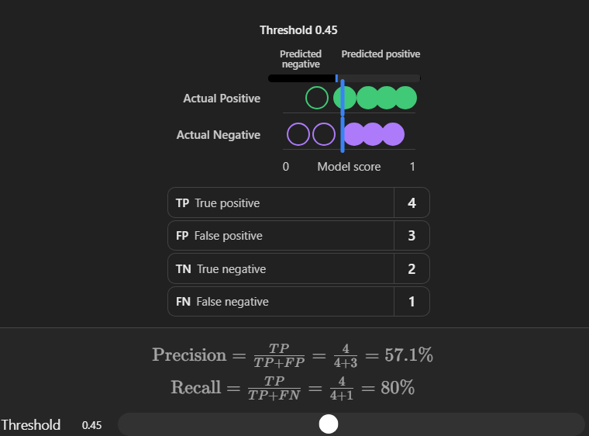

A lower threshold often increases recall but can reduce precision; the exact trade-off depends on the data and model.

F. MAE — Mean Absolute Error (regression)
Definition: The average absolute difference between actual numerical values and model predictions.
$$\text{MAE}=\frac{1}{n}\sum_{i=1}^{n}{\left|y_{i}-{\hat{y}}_{i}\right|}$$Where:
- $y_{i}$ = actual value
- ${\hat{y}}_{i}$= predicted value
- $n$= number of observations

Example:
Actual sales | Predicted sales | Absolute error
₹1,000 | ₹900 | ₹100
₹2,000 | ₹2,200 | ₹200
₹3,000 | ₹2,900 | ₹100

MAE = (100 + 200 + 100) ÷ 3 = ₹133.33 approximately.
This means the predictions differ from actual sales by an average absolute amount of about ₹133.33 in this example.
Important: MAE is measured in the same units as the target. It cannot be directly compared across targets measured in different units without additional context.

- Metric selection guide
Problem | Useful metric(s) | Why
Balanced classification | Accuracy, F1 | General correctness and balance between precision/recall
Fraud detection | Precision, recall, F1 | False alarms and missed fraud both matter
Customer churn prediction | Recall, precision, F1 | Identify likely-to-leave customers while managing false alerts
Sales prediction | MAE | Average magnitude of prediction errors
Imbalanced classification | Precision, recall, F1; possibly PR-AUC | Accuracy alone may hide poor detection
There is no single best metric for every project. Business costs and the consequences of mistakes should guide your choice.
- Train a simple model using Scikit-learn:

We'll build a flower classification model. It will use flower measurements to predict which of three Iris flower species a sample belongs to.

This is a good first project because Scikit-learn provides the dataset, so you can focus on learning the workflow rather than finding and cleaning a large file.

Step 1 — Install the required libraries
In your terminal or notebook, run this if the libraries are not already installed:

python -m pip install scikit-learn pandas matplotlib

Step 2 — Load the dataset and inspect it

import pandas as pd
from sklearn.datasets import load_iris

iris = load_iris(as_frame=True)

X = iris.data
y = iris.target

print(X.head())
print("Dataset shape:", X.shape)
print("Target names:", iris.target_names)
print("Class counts:")
print(y.value_counts().sort_index())

What this does:
- load_iris() loads a sample classification dataset.
- X contains four flower measurements.
- y contains the species class encoded as 0, 1, or 2.
- X.shape tells you the number of rows and feature columns.

This dataset contains 150 observations and four numerical features.

Step 3 — Split the dataset

from sklearn.model_selection import train_test_split
X_train, X_test, y_train, y_test = train_test_split(
X,
y,
test_size=0.2,
random_state=42,
stratify=y
)
print("Training rows:", len(X_train))
print("Testing rows:", len(X_test))

Why use stratify=y? It helps preserve the proportions of the three classes in both splits.
With 150 observations and a 20% test split, you get 120 training rows and 30 testing rows.

Step 4 — Train the model
We'll use Logistic Regression, a common classification algorithm. Despite its name, it is used for classification here.
from sklearn.pipeline import make_pipeline
from sklearn.preprocessing import StandardScaler
from sklearn.linear_model import LogisticRegression
model = make_pipeline(
StandardScaler(),
LogisticRegression(max_iter=1000)
)
model.fit(X_train, y_train)

Understand these three important lines:
- StandardScaler() standardizes the feature scales using statistics learned from the training data.
- LogisticRegression() creates the classification estimator.
- model.fit(X_train, y_train) trains the pipeline using the training examples.

Using a pipeline helps prevent data leakage from scaling because the scaler is fitted on the training portion, not the test portion.

Step 5 — Predict on unseen test data
y_pred = model.predict(X_test)
print("Actual classes:")
print(y_test.to_numpy())
print("Predicted classes:")
print(y_pred)
The model makes predictions for the test features it did not see during training.
A predicted class of 0, 1, or 2 corresponds to one of the three flower species.
Use iris.target_names to interpret those class codes.

Step 6 — Evaluate the classification model
from sklearn.metrics import (
accuracy_score,
precision_score,
recall_score,
f1_score,
classification_report,
confusion_matrix
)
print("Accuracy:", accuracy_score(y_test, y_pred))
print("Precision:", precision_score(
y_test, y_pred, average="weighted"
))
print("Recall:", recall_score(
y_test, y_pred, average="weighted"
))
print("F1-score:", f1_score(
y_test, y_pred, average="weighted"
))
print("\nClassification report:")
print(classification_report(
y_test, y_pred, target_names=iris.target_names
))
print("Confusion matrix:")
print(confusion_matrix(y_test, y_pred))

Why use average="weighted"? This combines the per-class precision, recall, or F1-score while weighting each class by its number of true observations. It is useful for multiclass classification, particularly when class sizes differ.

Your exact scores depend on the dataset split and model settings. With this fixed split, you should be able to reproduce the same result in the same compatible environment.

Step 7 — Predict a new flower
new_flower = pd.DataFrame(
[[5.1, 3.5, 1.4, 0.2]],
columns=X.columns
)
prediction = model.predict(new_flower)[0]
print("Predicted flower:", iris.target_names[prediction])

The model uses the measurements in the same column order and units as the training data to predict a species.
Real-world lesson: A model's prediction is not automatically correct. You must assess its performance on unseen data and understand whether its errors are acceptable for the intended use.

Practical regression example — Calculate MAE with Scikit-learn
You have now trained a classification model. Let's also practice the metric used for numerical predictions: MAE.
Suppose a store wants to predict sales from advertising expenditure. We'll create a small synthetic dataset for learning.

import numpy as np
from sklearn.model_selection import train_test_split
from sklearn.linear_model import LinearRegression
from sklearn.metrics import mean_absolute_error
# Example data
X = np.array([
[100], [200], [300], [400], [500],
[600], [700], [800], [900], [1000]
])
y = np.array([
120, 190, 310, 390, 510,
590, 720, 780, 910, 980
])
# Split the data
X_train, X_test, y_train, y_test = train_test_split(
X, y,
test_size=0.2,
random_state=42
)
# Train a regression model
model = LinearRegression()
model.fit(X_train, y_train)
# Predict on test data
y_pred = model.predict(X_test)
# Calculate MAE
mae = mean_absolute_error(y_test, y_pred)
print("Actual values:", y_test)
print("Predicted values:", y_pred)
print("Mean Absolute Error:", mae)

Understand the output
- LinearRegression() creates a model for predicting a numerical value.
- .fit() learns the relationship between advertising expenditure and sales.
- .predict() estimates sales for the test observations.
- mean_absolute_error() measures the average absolute prediction error.
The data here is deliberately small and synthetic. It demonstrates the mechanics of training and evaluation, not a reliable business forecasting system.

Regression visualization

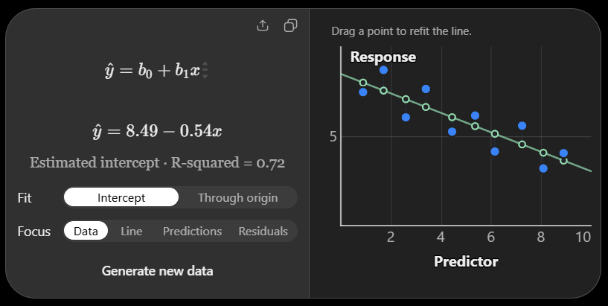
The line represents the model's predictions, while the vertical gaps between the observed points and the line represent residuals. The absolute sizes of these gaps are what MAE averages.

Complete machine learning workflow
Use this sequence as your reference for future projects.
- Define the problem. Decide what you want to predict or discover and how the result will be used.
- Collect the data. Obtain relevant data from databases, CSV files, APIs, or other approved sources.
- Explore and clean. Inspect data types, missing values, duplicates, invalid values, and target distribution.
- Define features and target. Identify the input columns (X) and, for supervised learning, the target (y).
- Split the data. Keep a test set aside and use training data for fitting.
- Preprocess the data. Apply suitable transformations, such as scaling or encoding, using a pipeline to avoid leakage.
- Train the model. Fit an appropriate algorithm to the training data.
- Evaluate and improve. Choose metrics that match the business problem, check generalization, and tune using validation data or cross-validation.
- Test the final model. Evaluate it on held-out test data after completing model selection.
- Communicate and monitor. Report performance, limitations, risks, and whether the model remains useful as new data arrives.

Common beginner mistakes to avoid
- Training and testing on the same observations, which gives an unreliable estimate of performance.
- Choosing accuracy alone for an imbalanced classification problem.
- Using classification for a numerical target without considering whether the target is actually a category.
- Scaling or imputing the entire dataset before splitting it, which can cause data leakage.
- Tuning repeatedly against the test set, gradually turning it into a validation set.
- Assuming correlation proves causation.
- Treating a high model score as proof that a model is ready for business use.
- Forgetting that a model can become less accurate when real-world data changes.

Learning Outcomes:
Machine learning is not just about choosing an algorithm.
A good analyst defines the problem correctly, prepares appropriate data, prevents leakage, selects meaningful metrics, tests generalization, and communicates the limitations of the results.

DAY 15 — Git, GitHub and Foundation Assessment

Date:-29/10/2026

Task: Learn version control and demonstrate the skills covered during training.

1. Install Git and configure a GitHub account.
2. Learn repositories, commits, and branches.
3. Upload Python notebooks and SQL files.
1. Write a README explaining the work.
2. Complete a practical assessment covering Python, Pandas, SQL, statistics, and visualization. 3. Explain one SQL query and one chart to the mentor.

- Install Git and configure a GitHub account:

Step 1 — Install Git
- Open the official website: Git for Windows.
- Download the Windows installer.
- Run the downloaded .exe file.
- You can keep the default installation options unless your mentor has specified otherwise.
- Finish the installation.

Step 2--Open Command Prompt and enter:
git --version

Step 3--Configure your identity
Use the same name and email you want associated with your commits.
git config --global user.name "Your Name"
git config --global user.email "your-email@example.com"

Step 4 --Create or configure your GitHub account
- Visit GitHub.
- Create an account or sign in.
- Verify your email if requested.
- Choose a professional username suitable for your portfolio.
- Keep your password and verification codes private.

- Learn repositories, commits, and branches:
These are the three Git concepts you need to understand today.
Term | Definition | Small example
Repository (repo) | A project folder tracked by Git | Your data-analytics-internship folder
Commit | A saved checkpoint of tracked changes | “Added SQL aggregation practice”
Branch | A separate line of development | Experiment with a new chart without changing your main version
Essential Git commands
- git init
Initializes Git tracking in the current folder.
- git status
Shows changed, staged, and untracked files.
- git add .
Stages current changes for the next commit. Review git status first so you don't accidentally stage unnecessary files.
- git commit -m "Add foundation assessment"
Records a checkpoint with a descriptive message.
- git log --oneline
Shows a compact history of commits.
To create and switch to a new branch:
- git switch -c practice-branch
When you want to return to the main branch:
- git switch main
A commit is stored in your local repository; it does not automatically upload your work to GitHub.

- Upload Python notebooks and SQL files.
- Write a README explaining the work.
- Complete a practical assessment covering Python, Pandas, SQL, statistics, and visualization. 3. Explain one SQL query and one chart to the mentor.

